AWS Task-4

**AWS Task-4**

**Task Description:**

Launch an EC2 instance (Linux and Windows) along with a web server. Then, create an EBS volume of 5 GB, attach it to an EC2 machine (Linux and Windows), and take a snapshot. Finally, create an EBS volume using the taken snapshot.

**Techstacks needs to be used :**

* AWS EBS
* AWS EC2

**Launch EC2 Instances (Linux & Windows)**

**Launch Linux EC2**

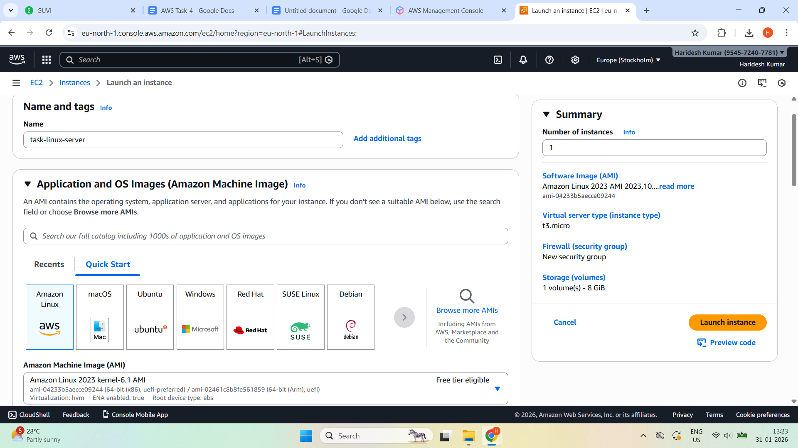

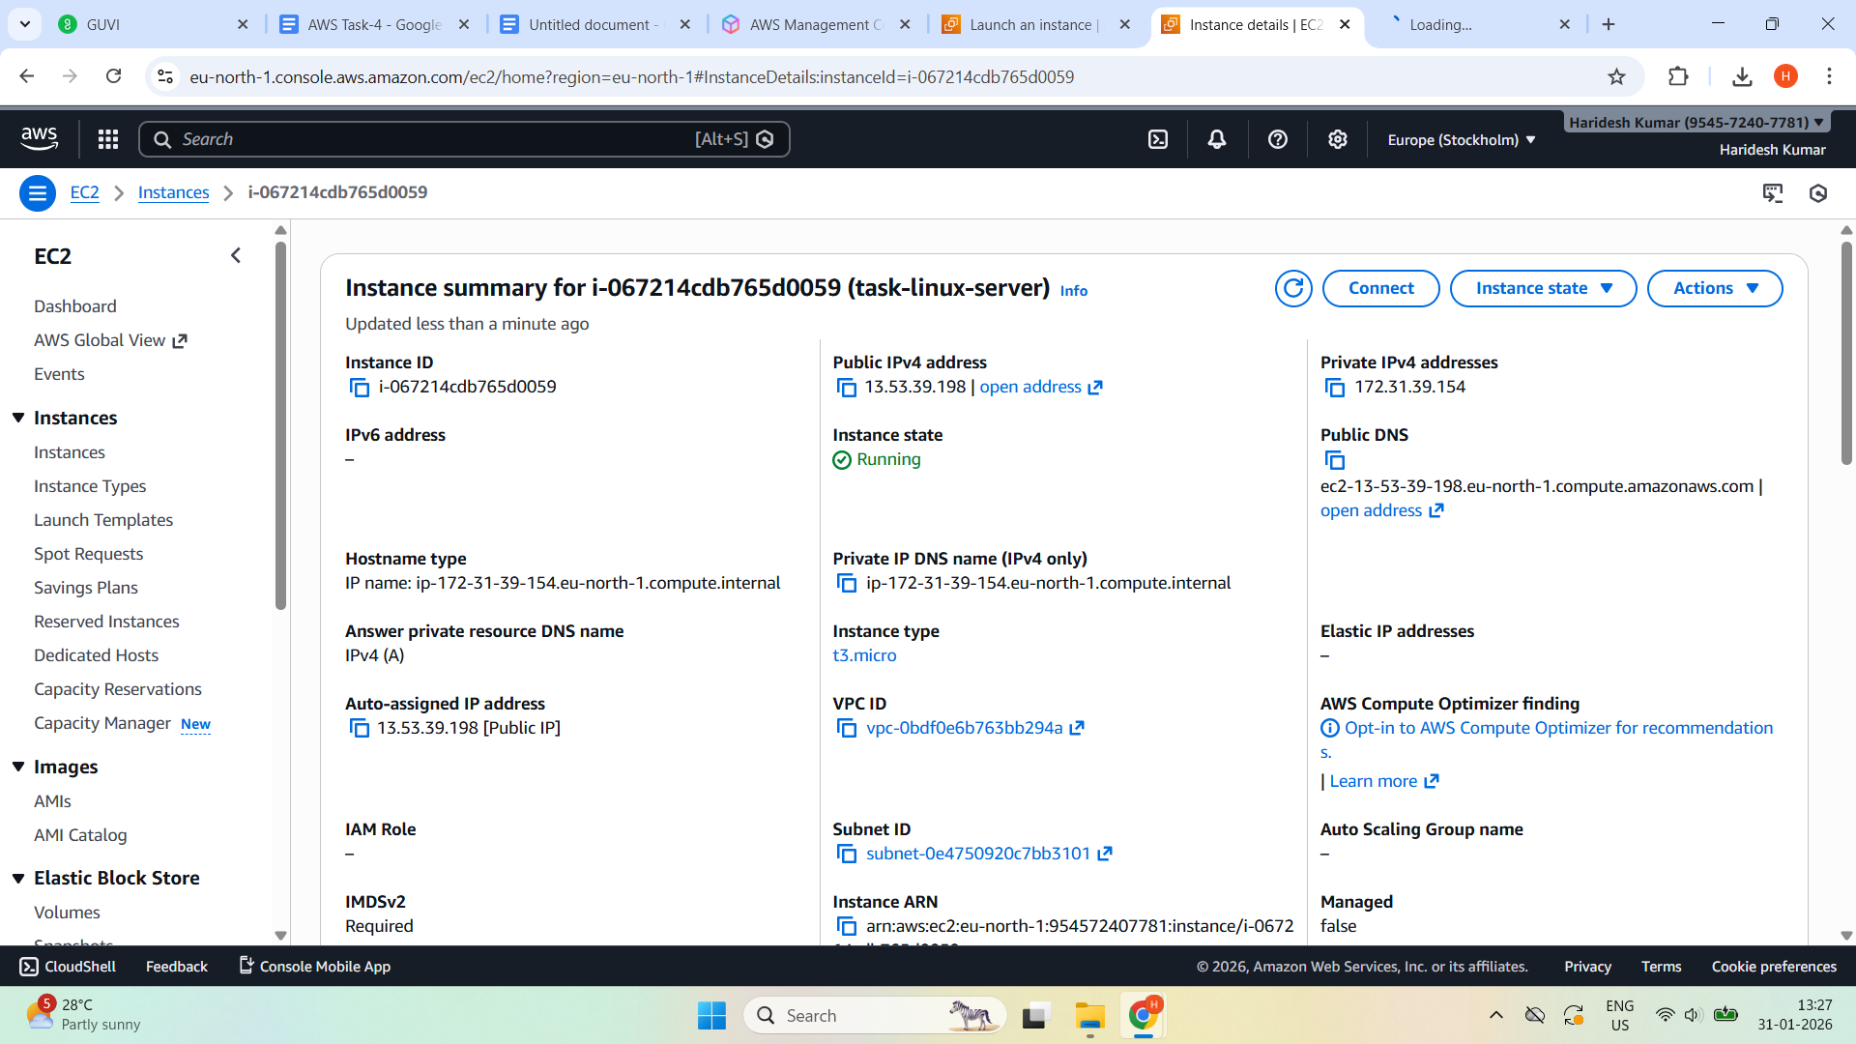

**Launch Windows EC2**

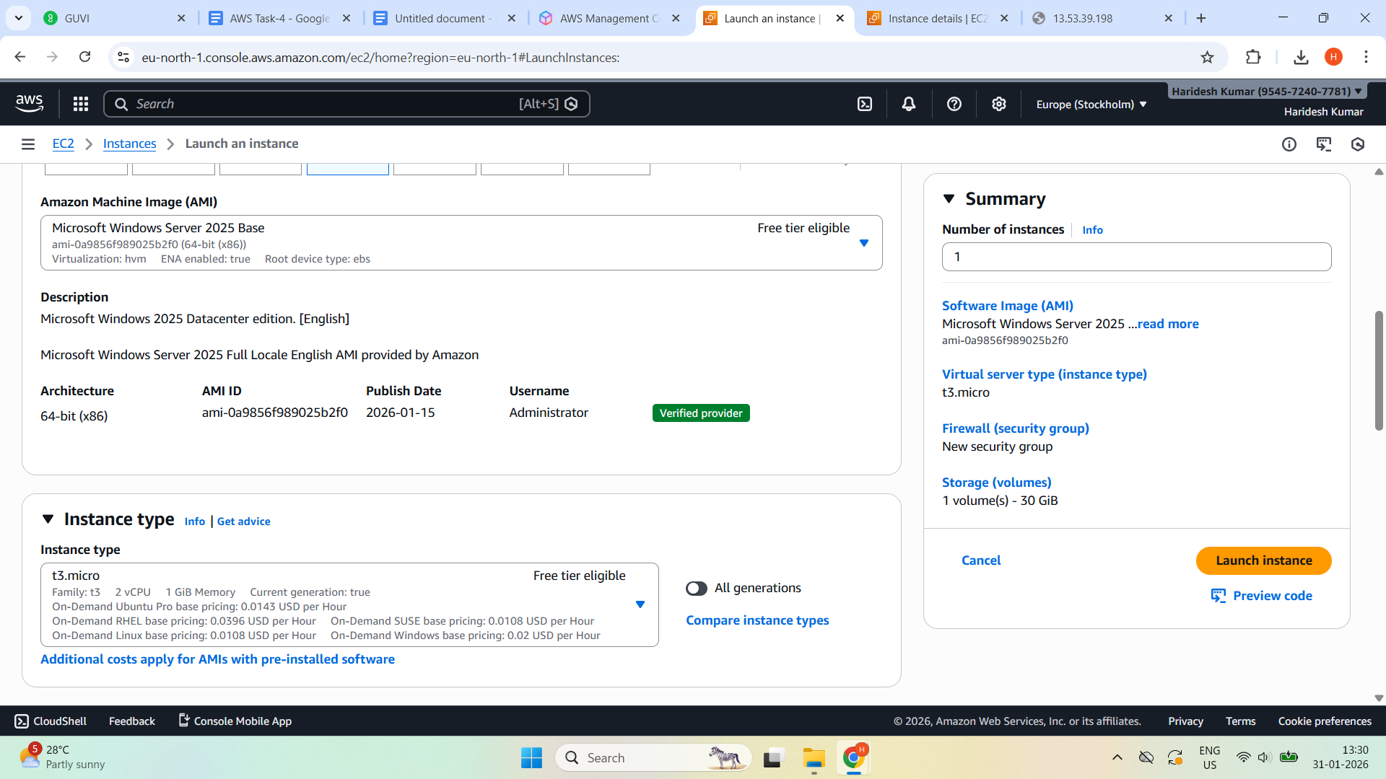

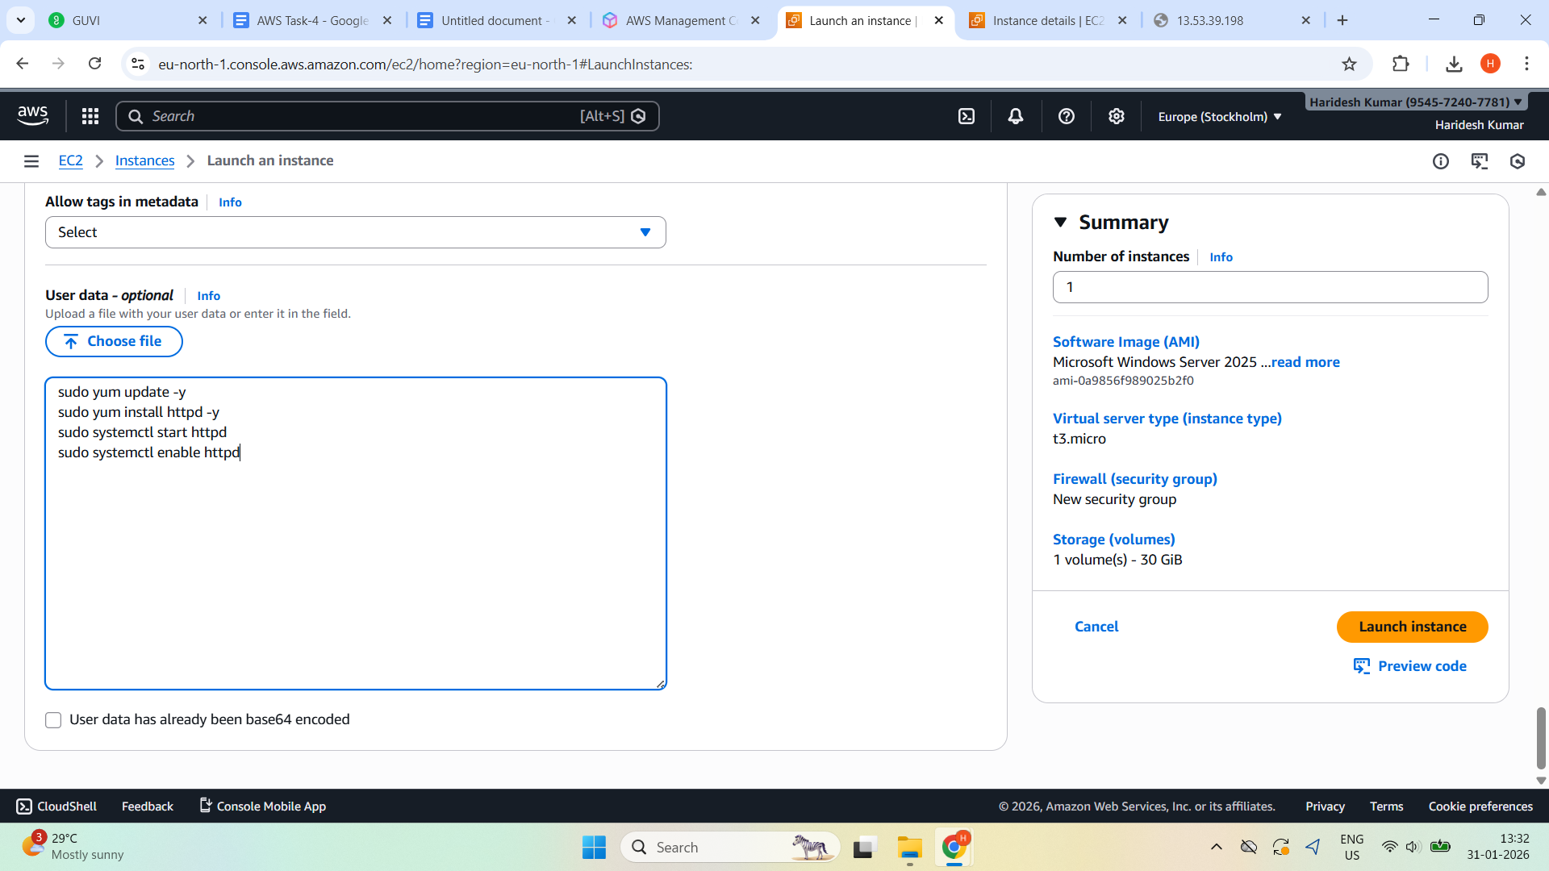

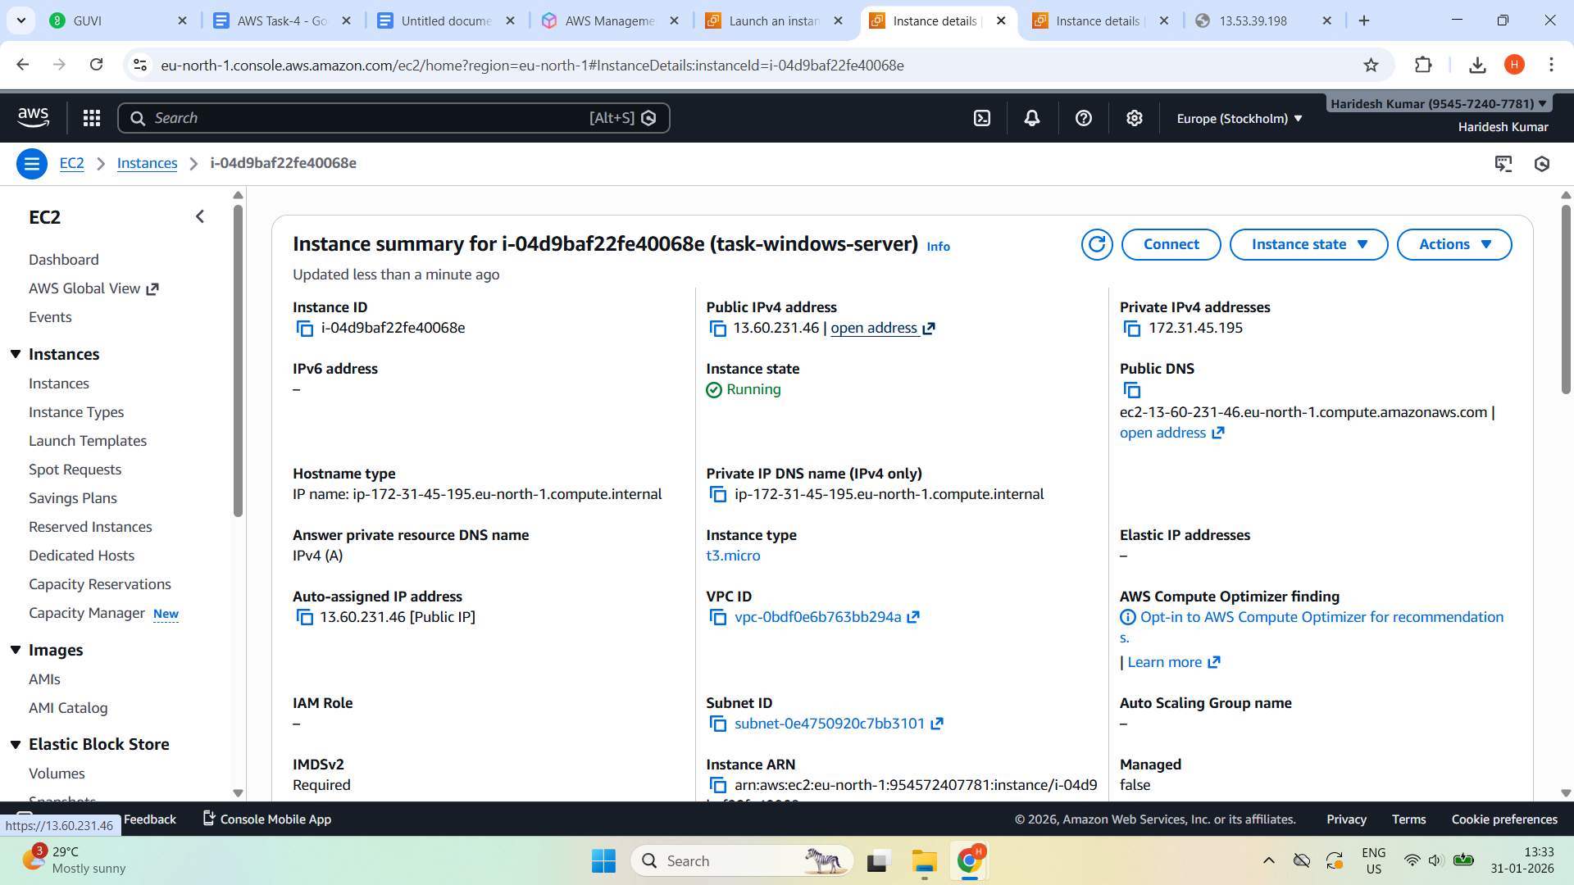

**Install Web Server on Linux EC2 and Connect using SSH  
Run:**

sudo yum update -y

sudo yum install httpd -y

sudo systemctl start httpd

sudo systemctl enable httpd

**Open browser:**

http://<Linux-Public-IP>

[**http://13.53.39.198/**](http://13.53.39.198/)

**Expected Result:**

Apache web page is displayed and Linux web server is working



**Once Launched Windows EC2 Instance**

**Get Password via RDP client and Windows desktop opens successfully**

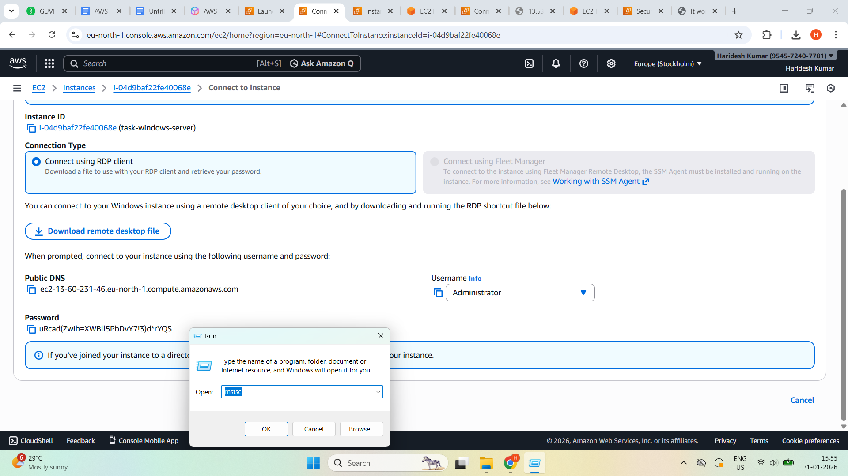

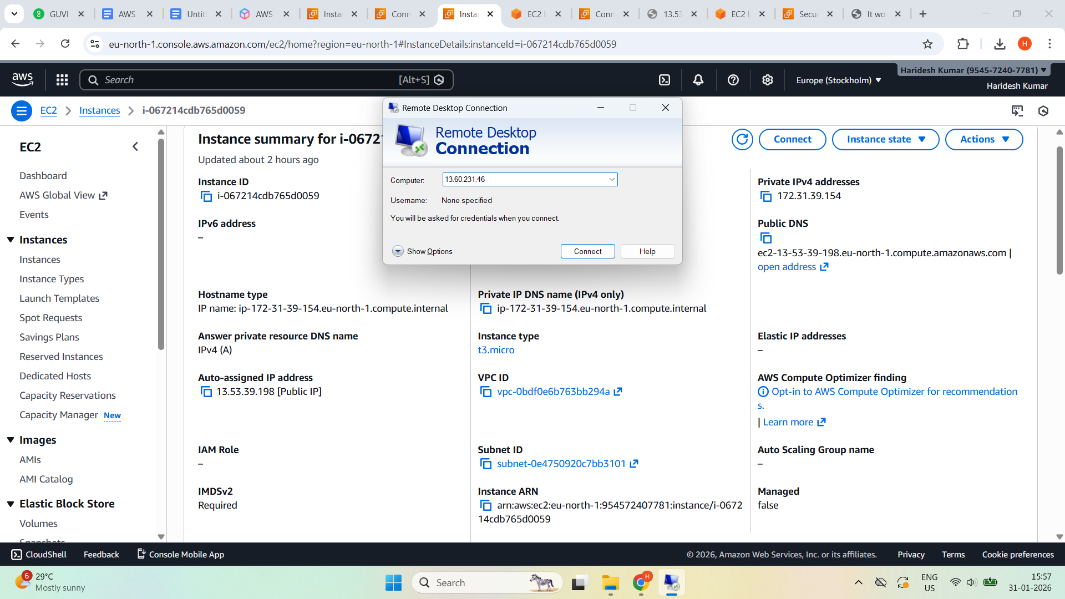

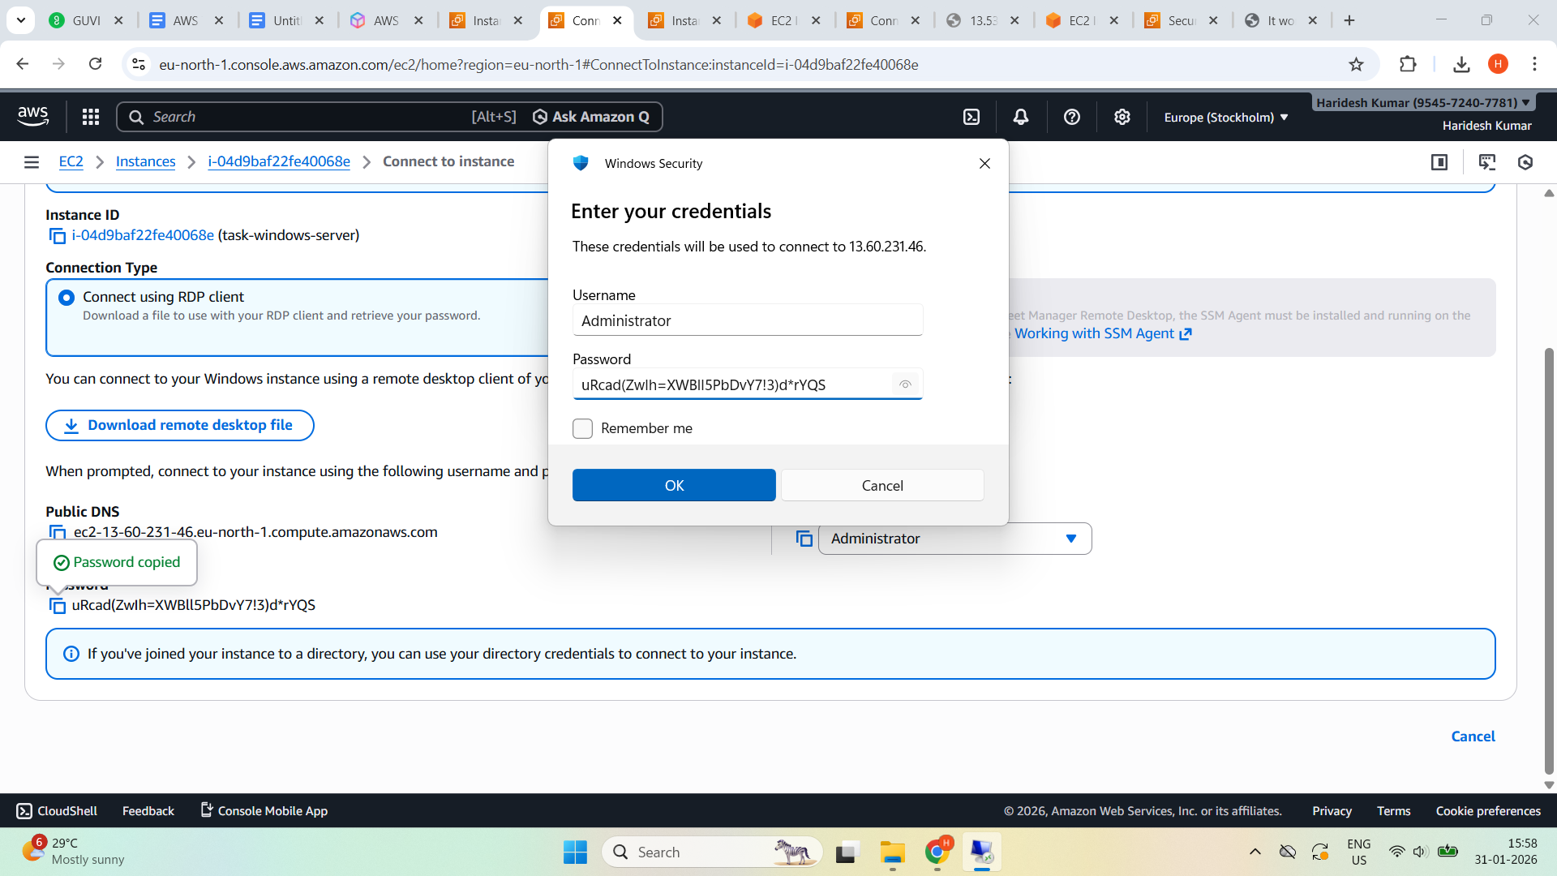

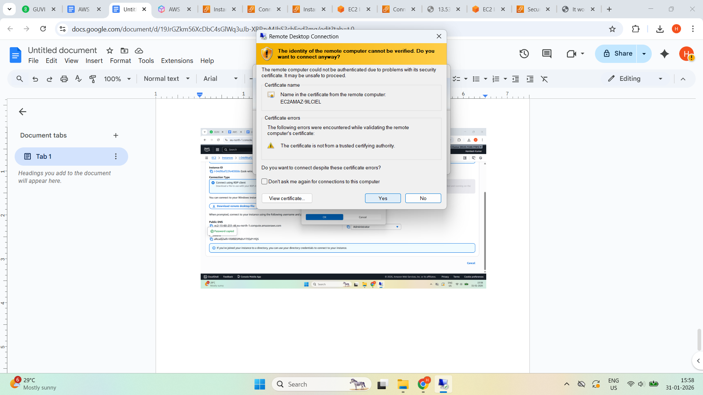

**Windows desktop opens successfully**

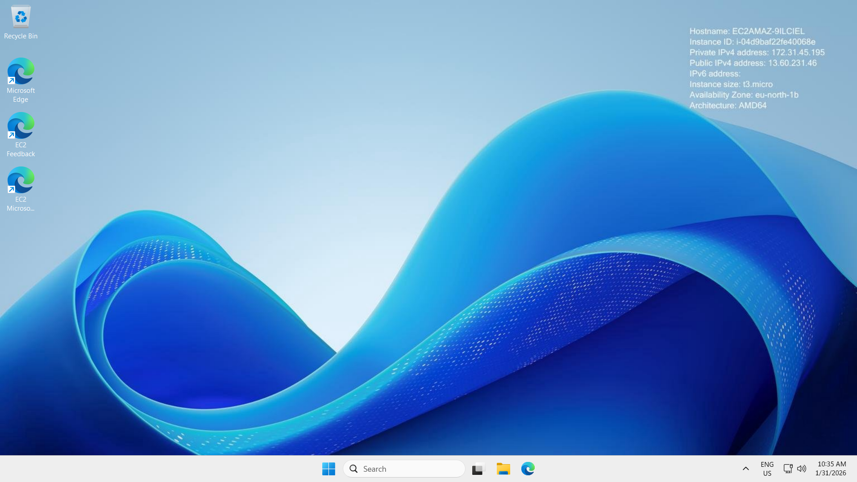

**Install Web Server (IIS) on Windows EC2**

**Open server manager inside a windows EC2 server**

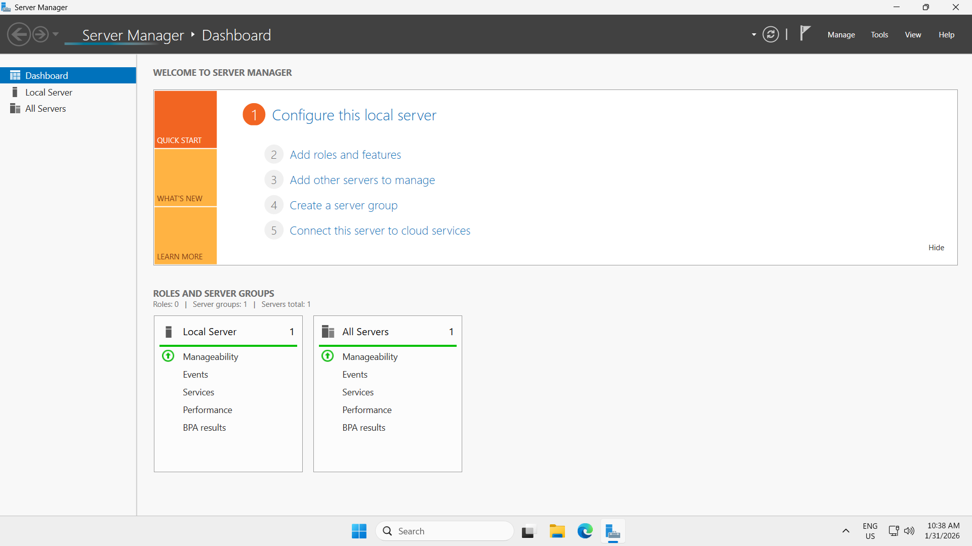

**Add Roles and features**

**Server selection —> server roles—> select web server IIS —->click Add features—>Click Next —> features —> Install**

**(Refer Below Screenshots)**

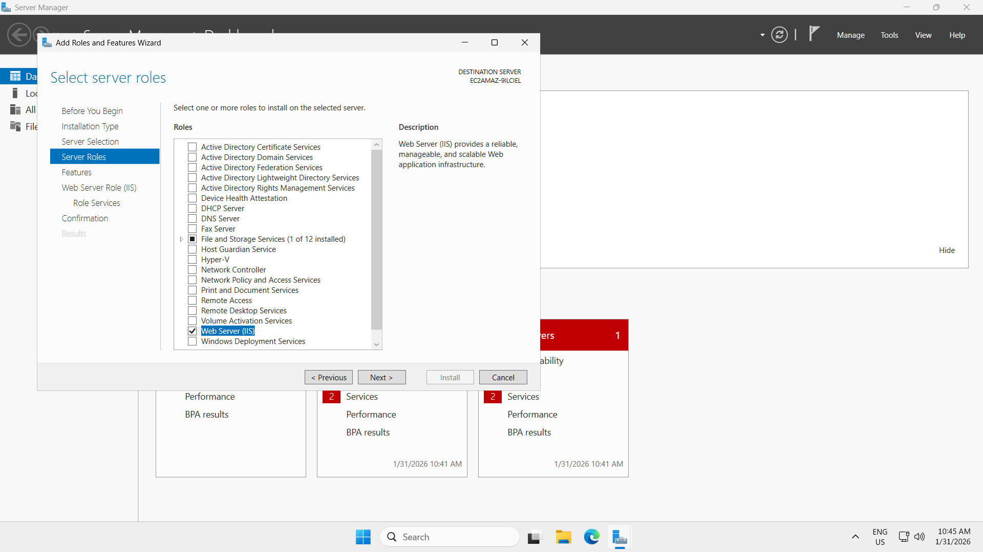

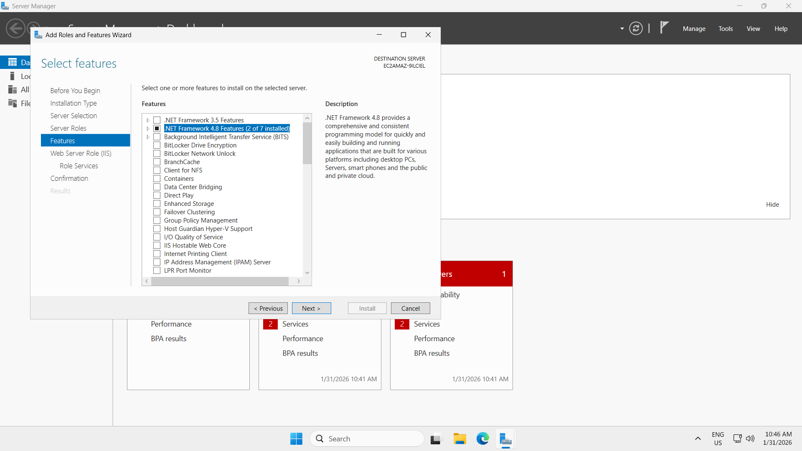

**Starting Installation**

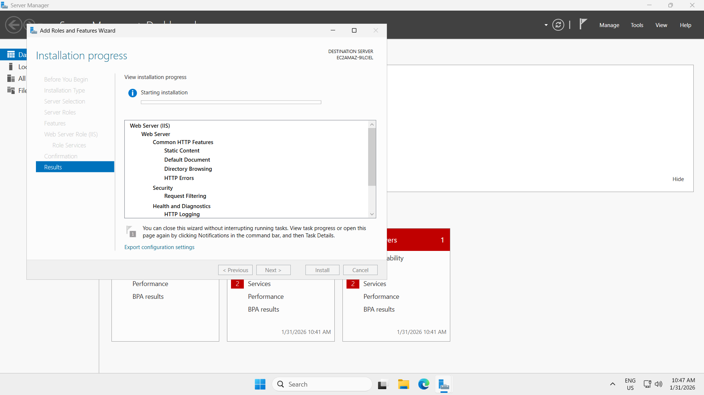

**Feature Installation started**

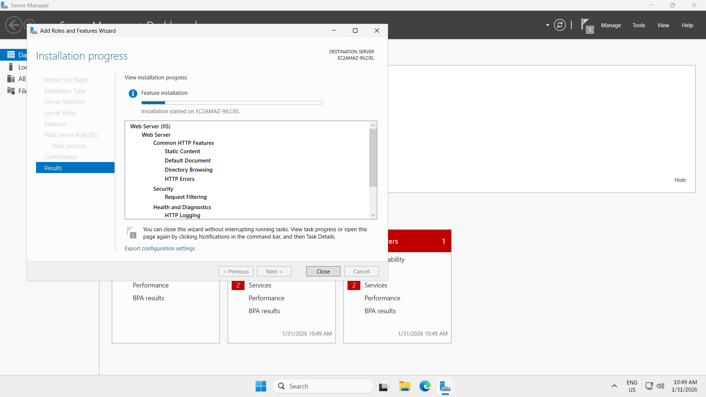

**Installation succeeded.**

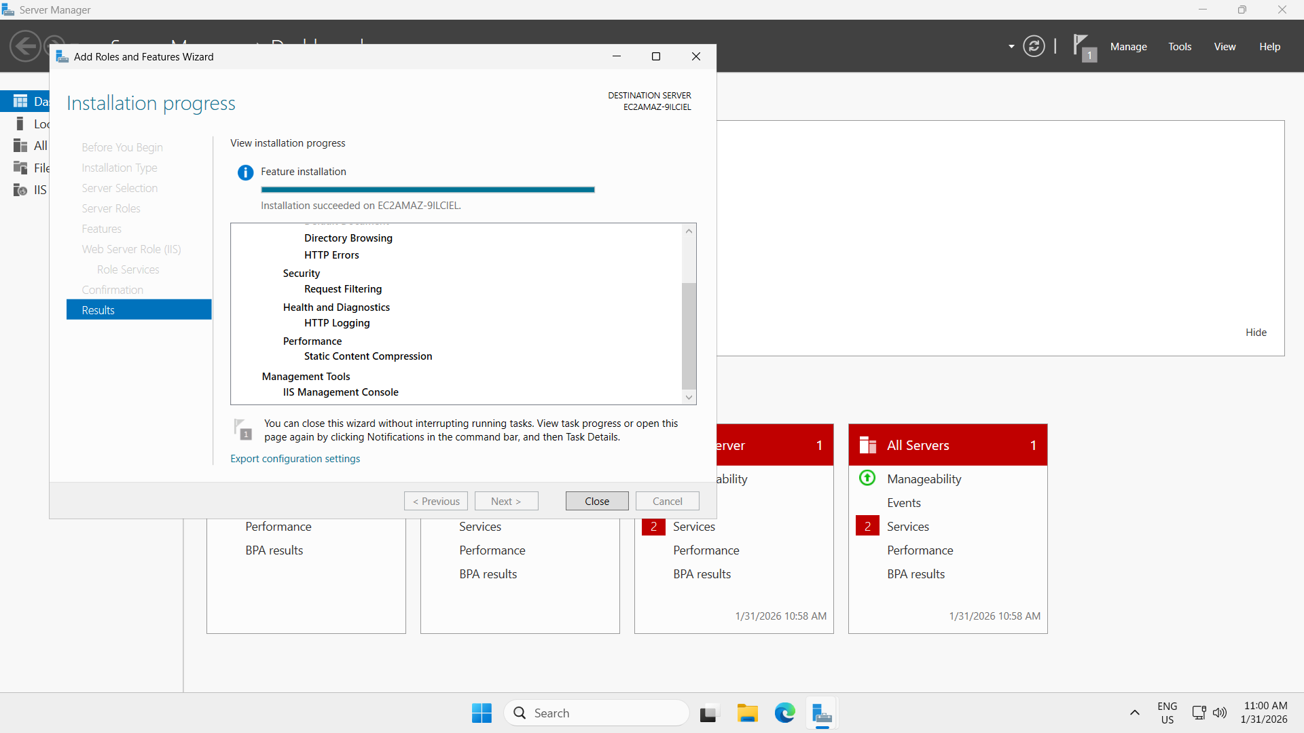

**Open a browser inside the EC2 windows instance (RDP session) and will see the IIS default Page**

**Go to:** [**http://localhost**](http://localhost)

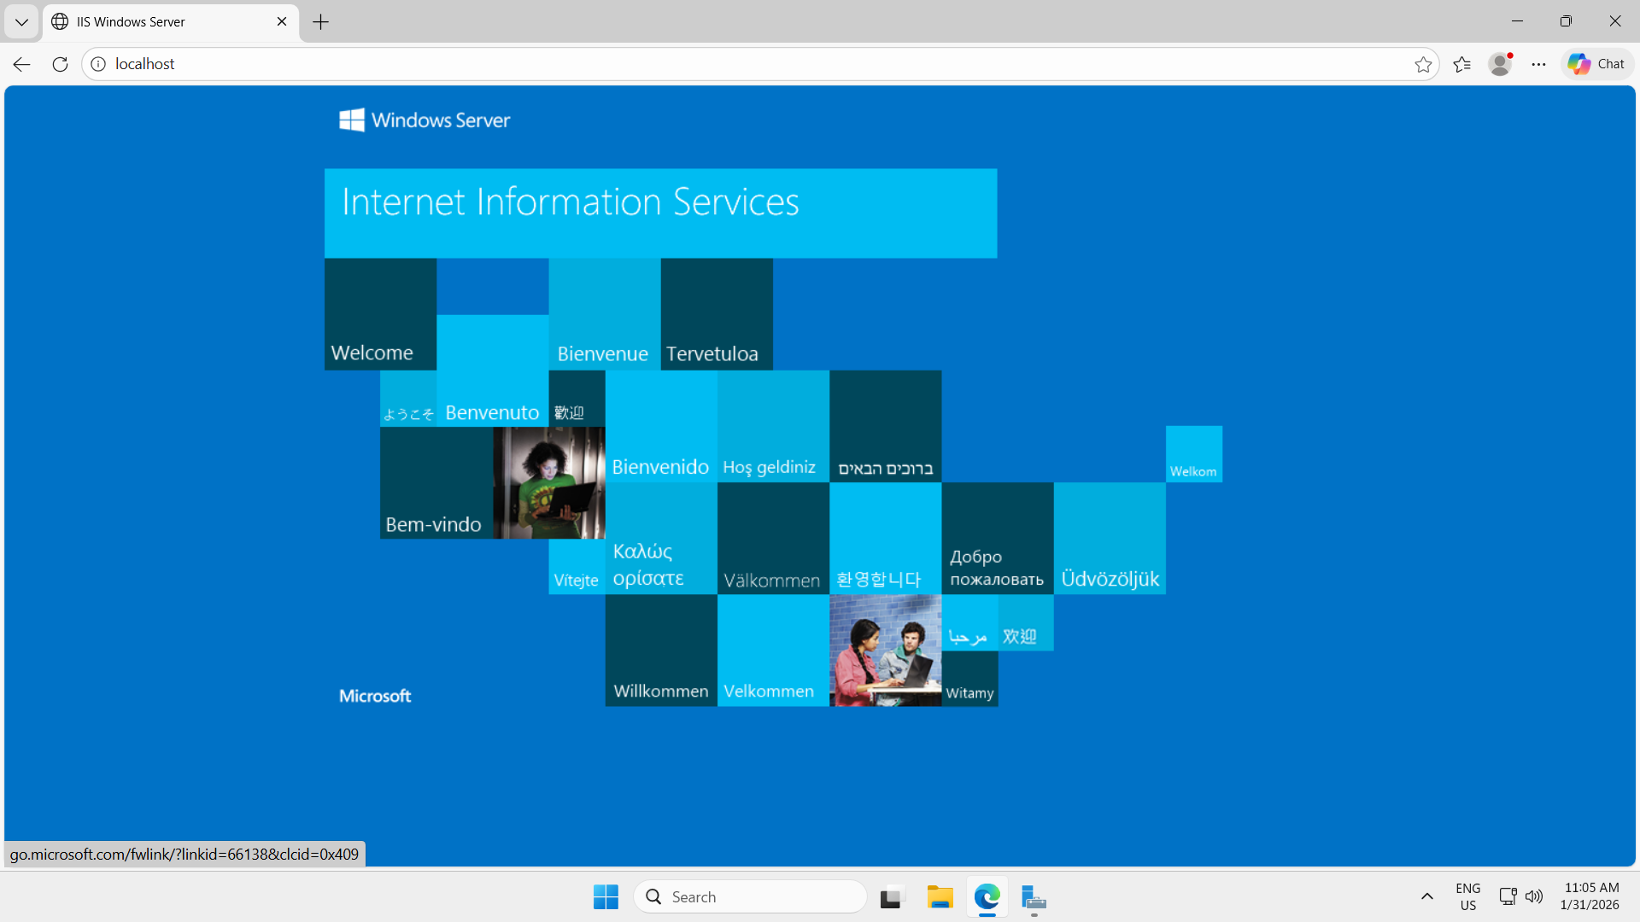

**Outside the EC2 window (from local system) and IIS is accessible from outside as well.**

**Go to: http://13.60.231.46/**

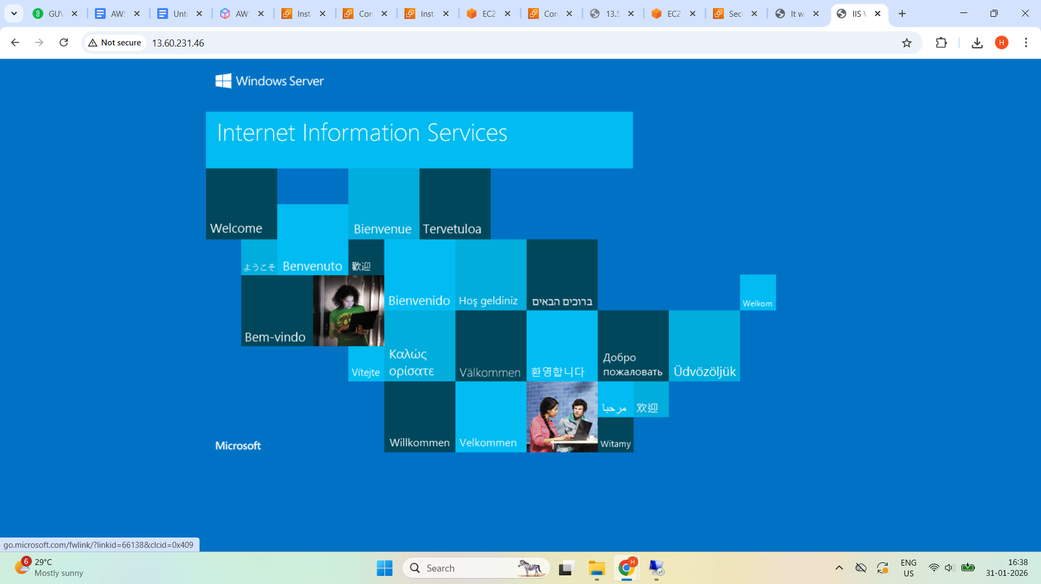

**Create 5 GB EBS Volume**

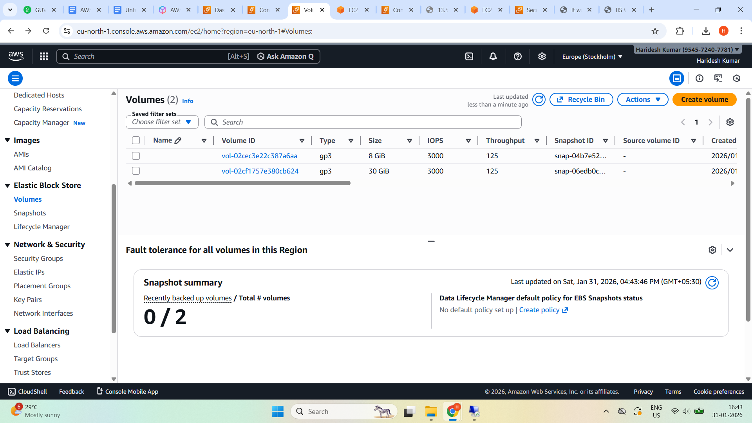

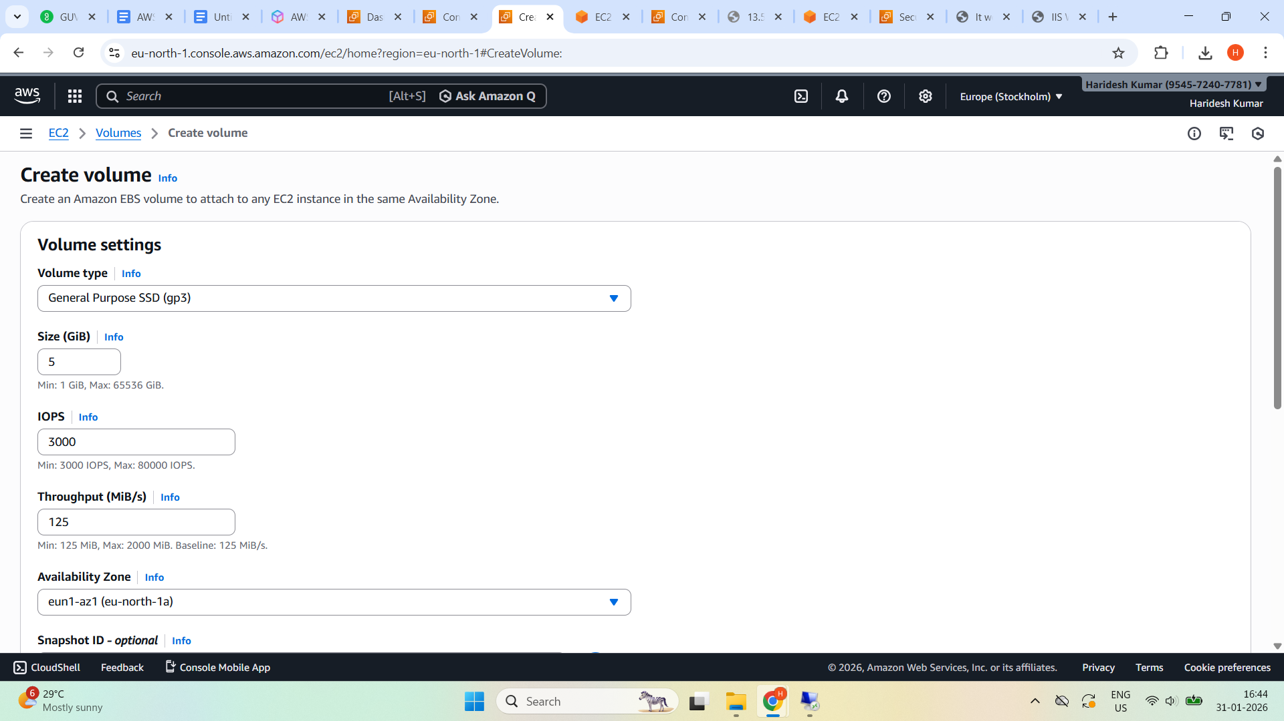

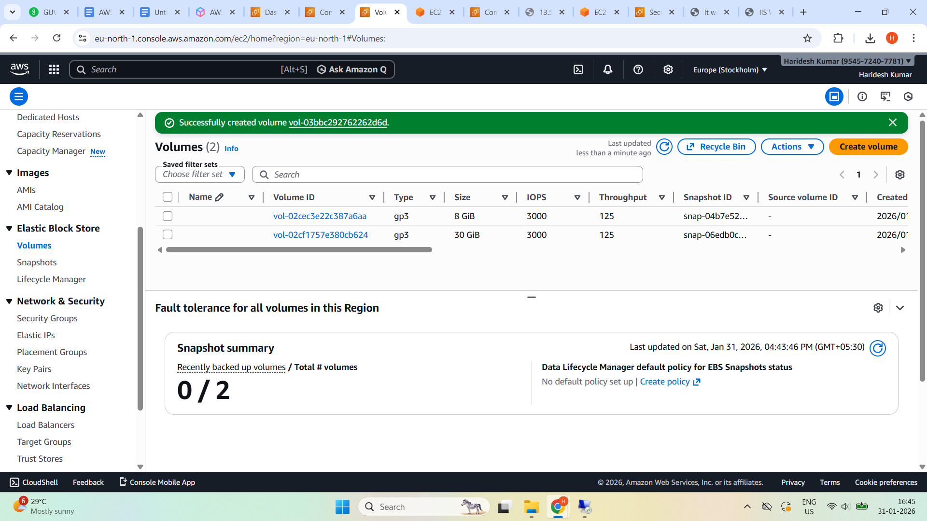

**EBS volume state is Available**

**Attach EBS to Linux EC2**

**Select Attach Volume and choose EC2**

**Availability zone same for ec2 and volume.**

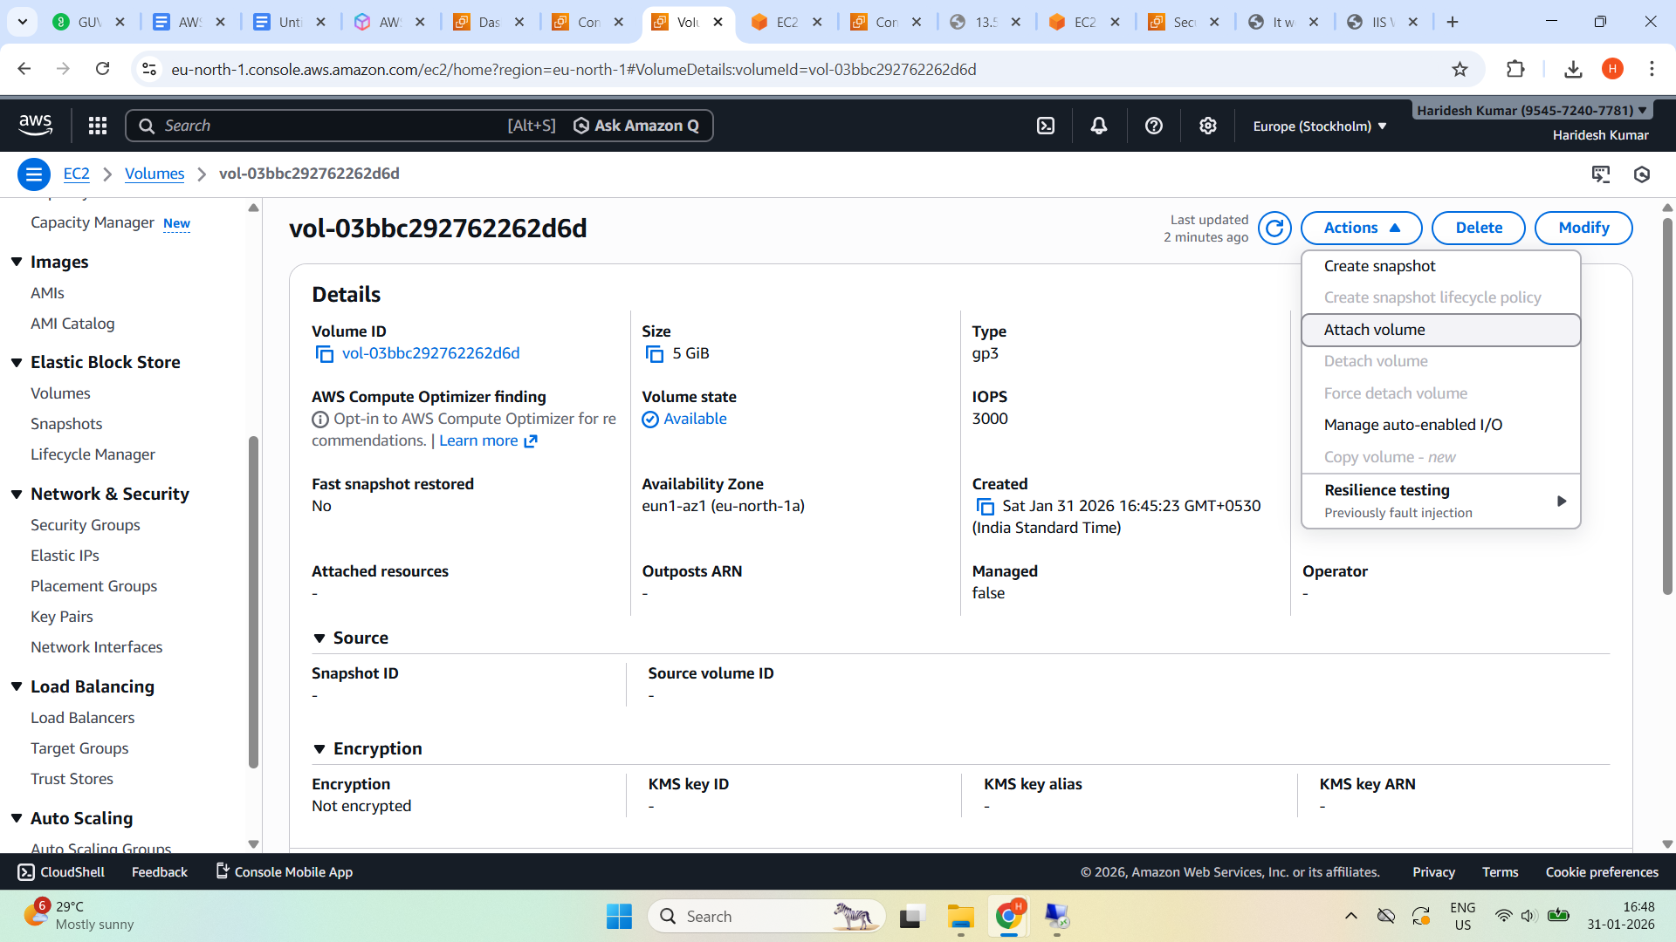

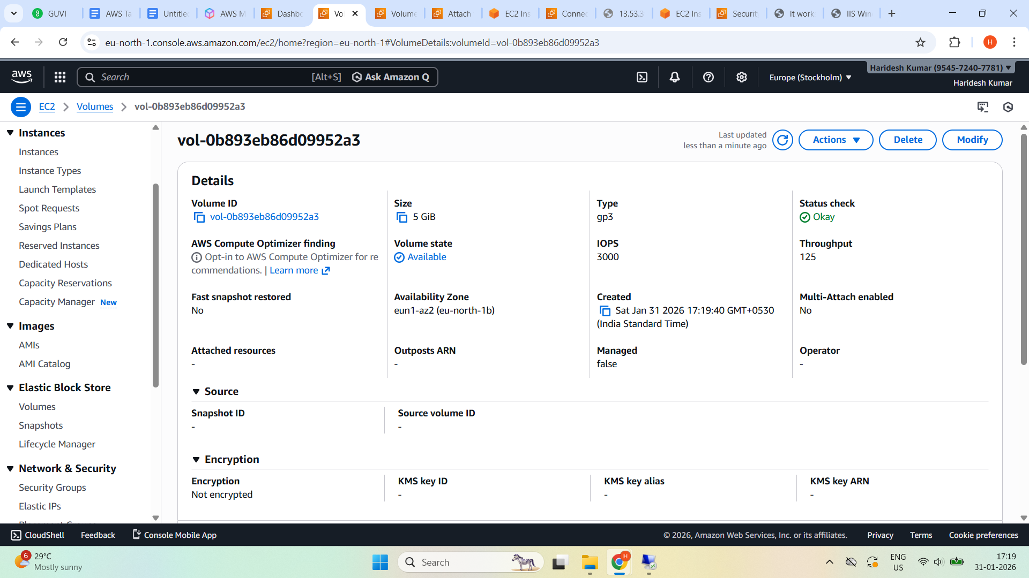

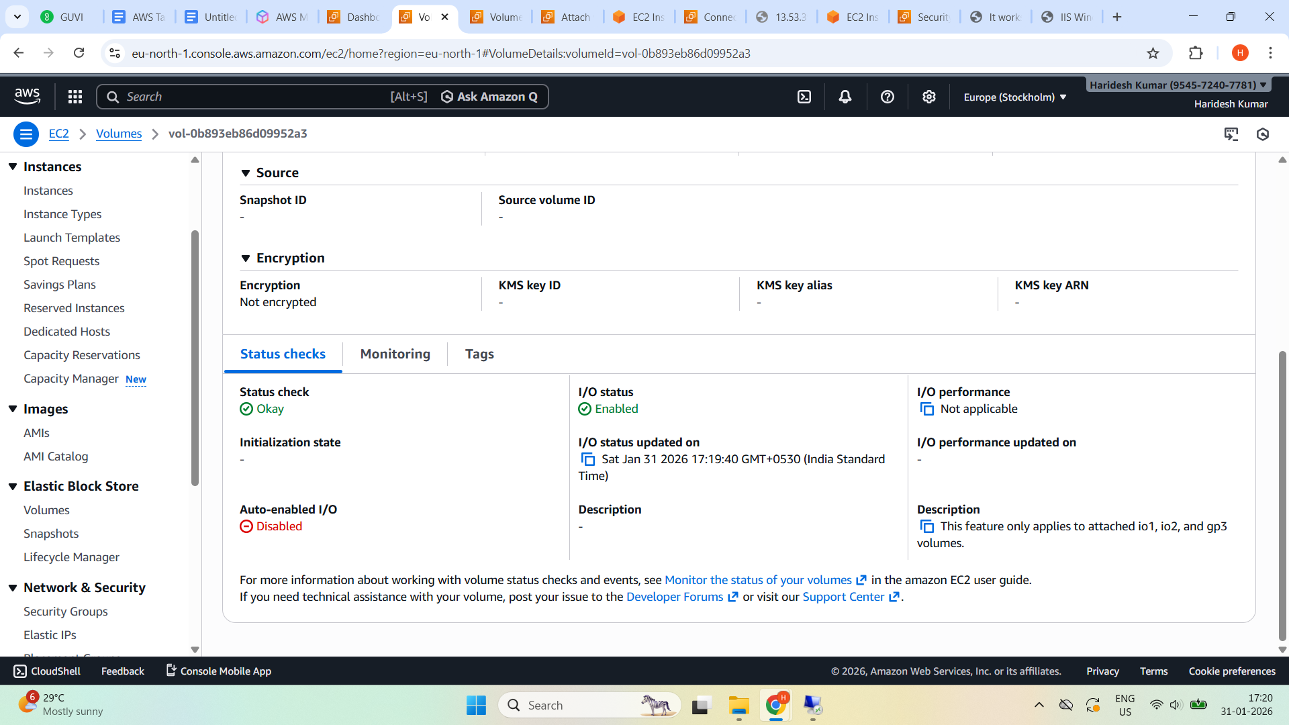

**Select Attach Volume and choose linux ec2 and device name /dev/xvdf**

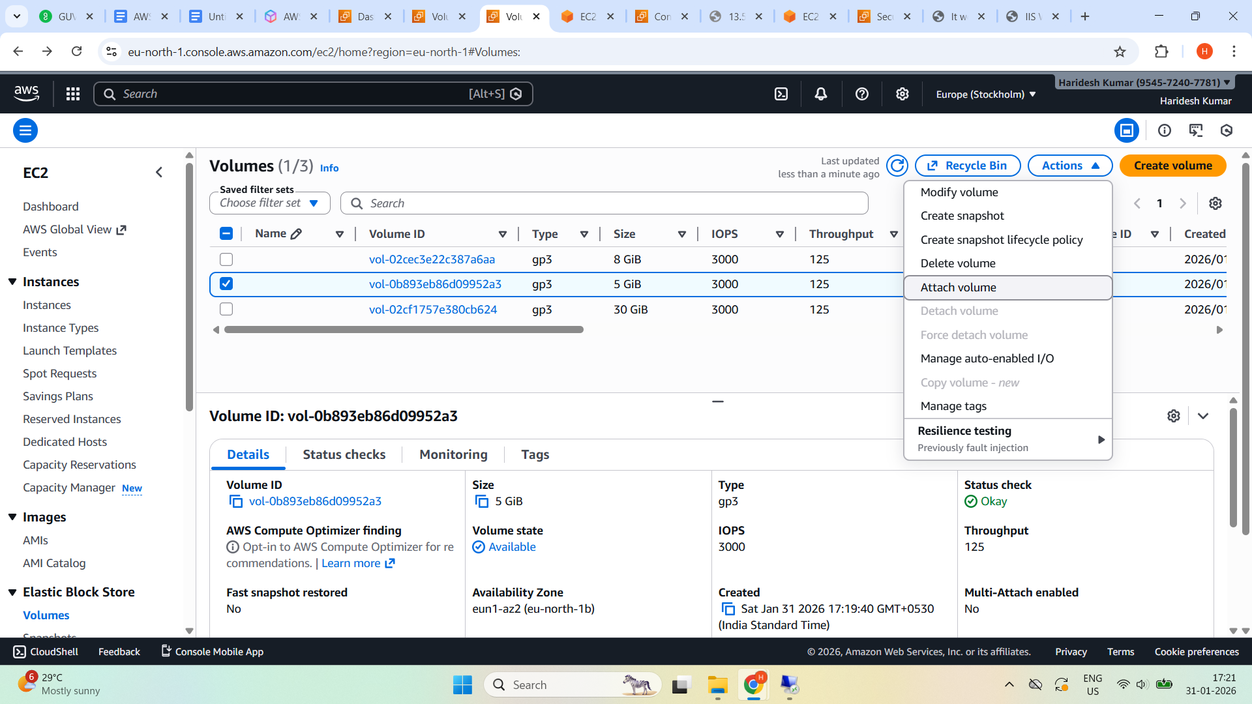

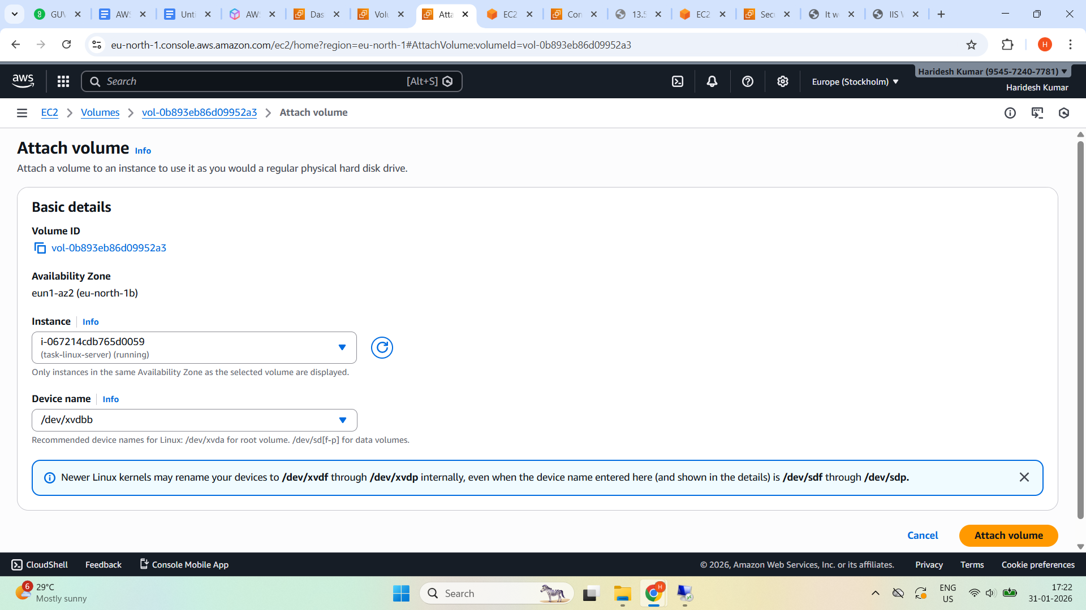

**Attached volume to the EC2 linux**

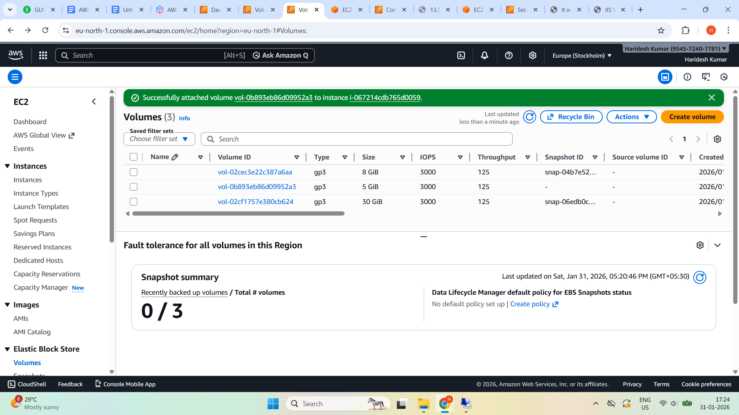

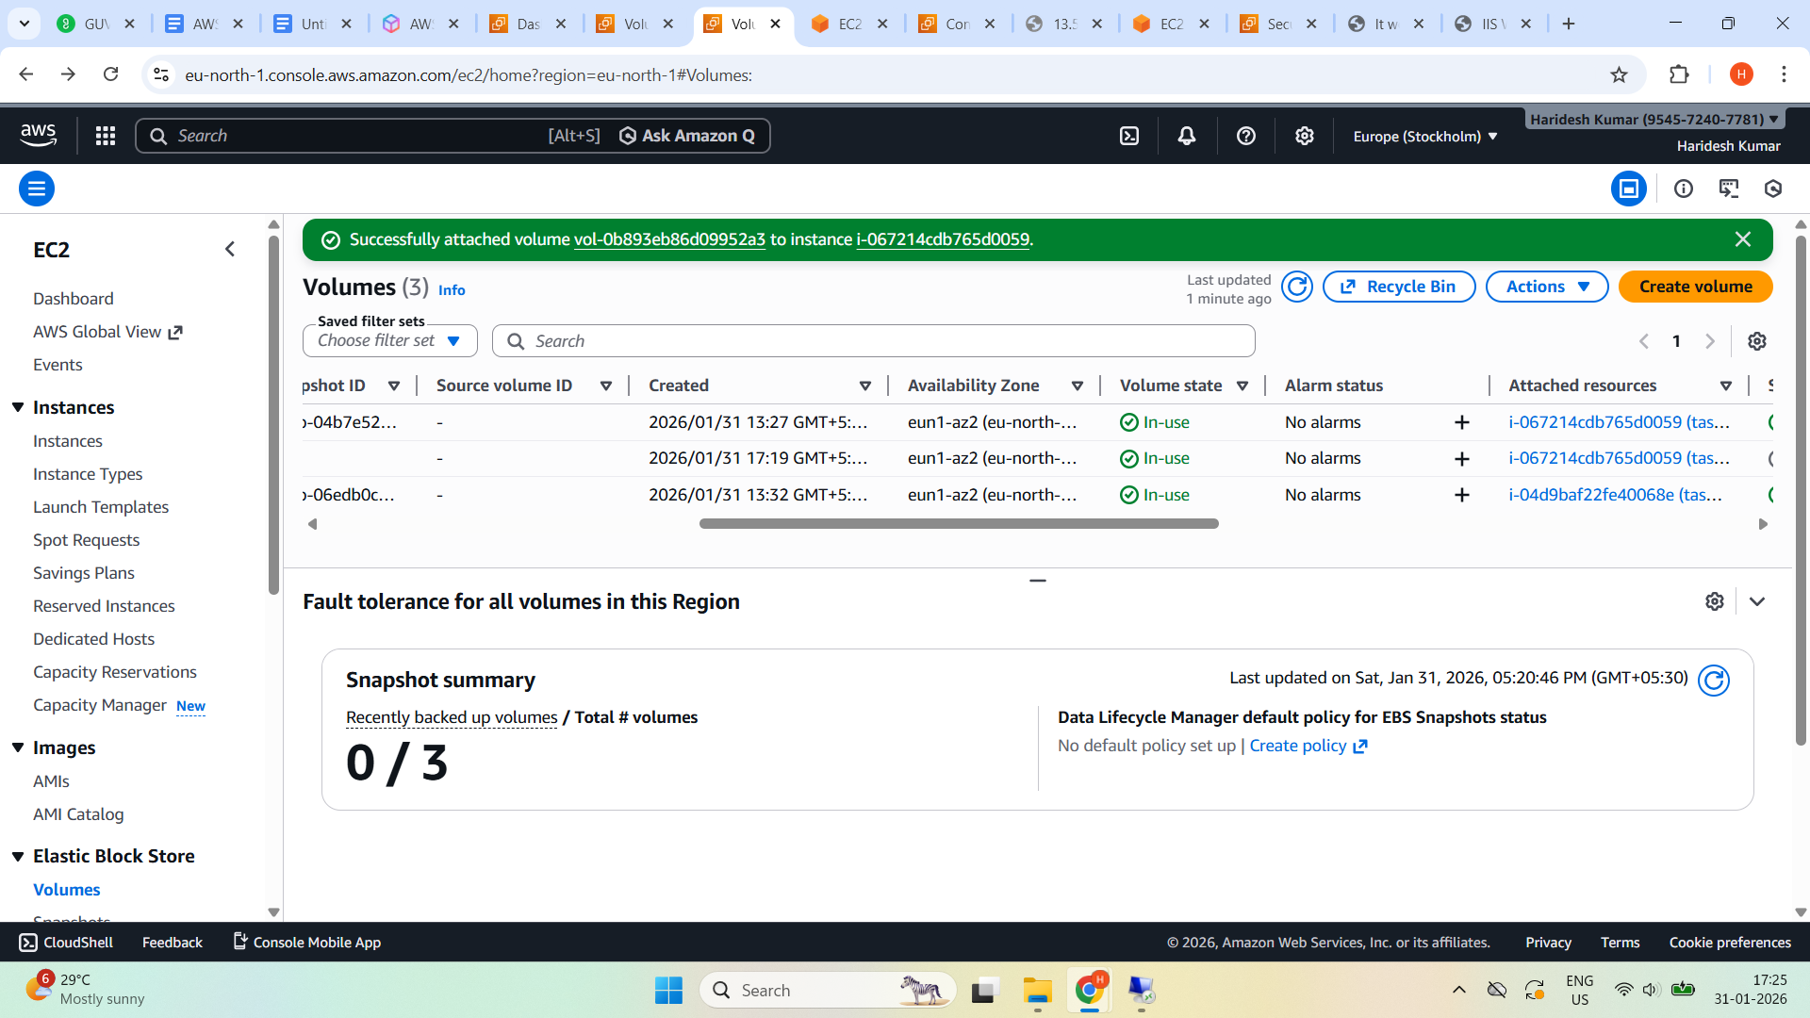**Mount on Linux**

lsblk

sudo mkfs -t ext4 /dev/xvdbb

sudo mkdir /data

sudo mount /dev/xvdbb /data

df -h

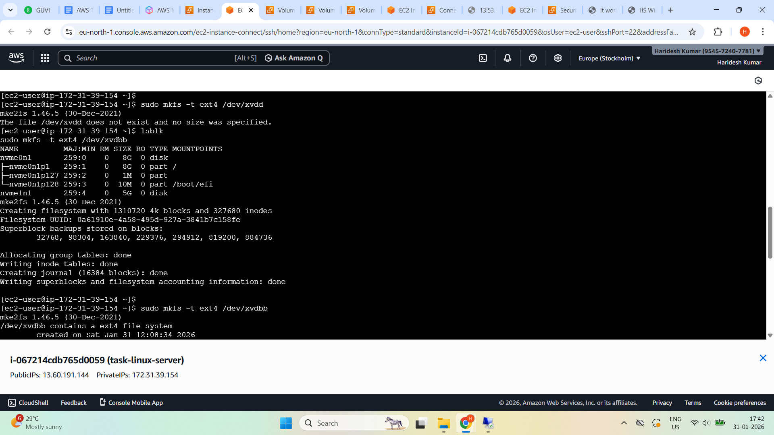

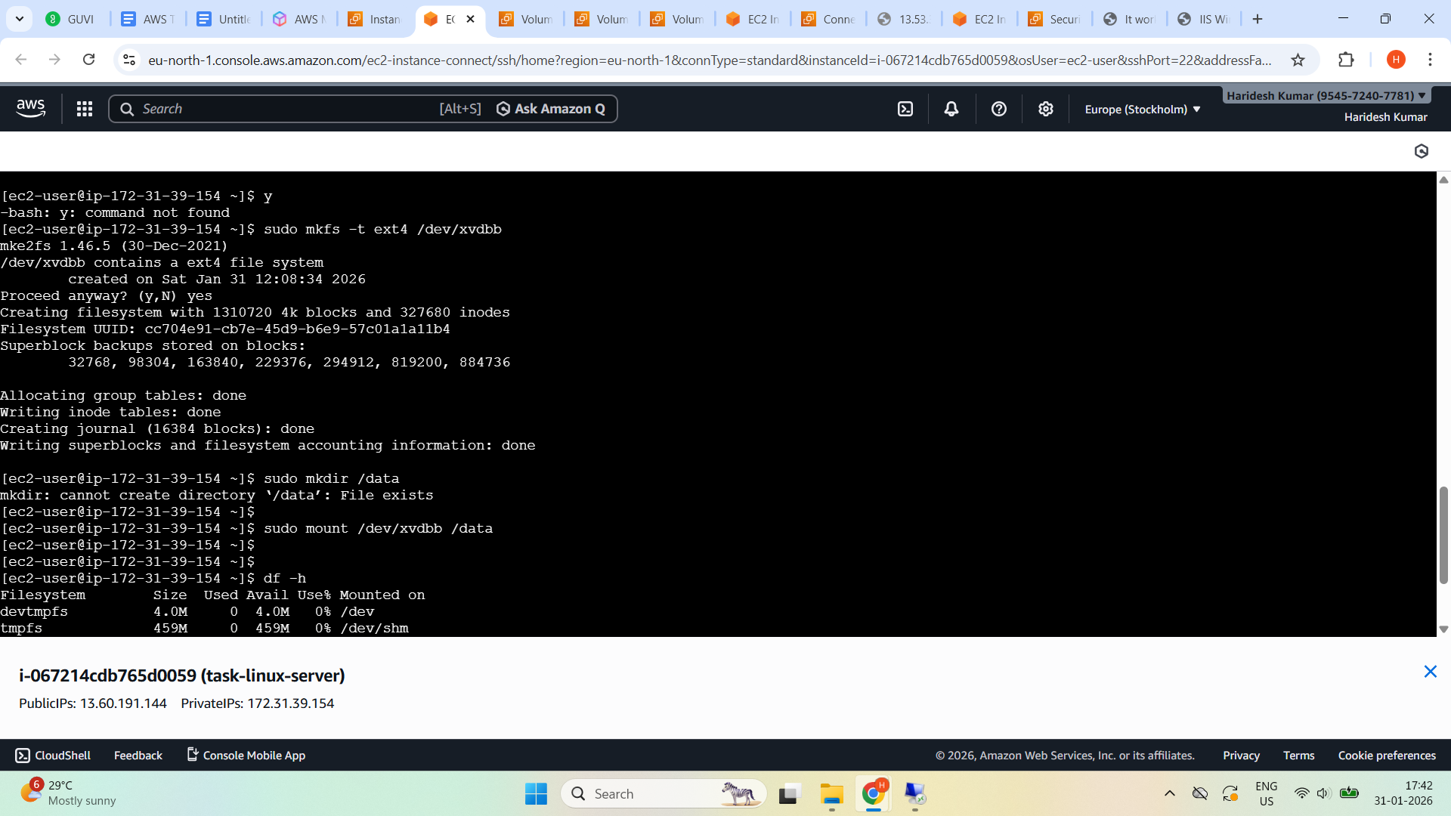

**Expected**: 5 GB EBS mounted at /data

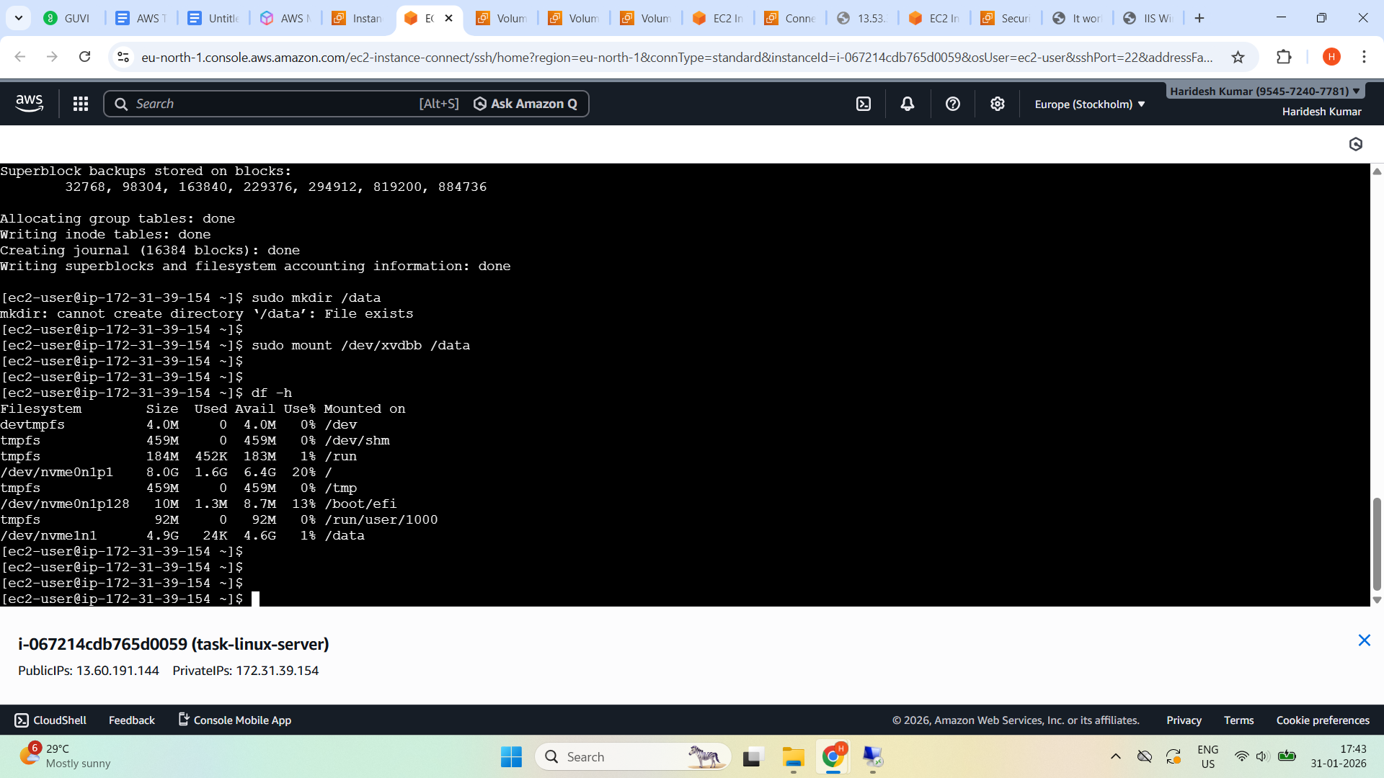

**Attach EBS to Windows EC2**

**Created another volume**

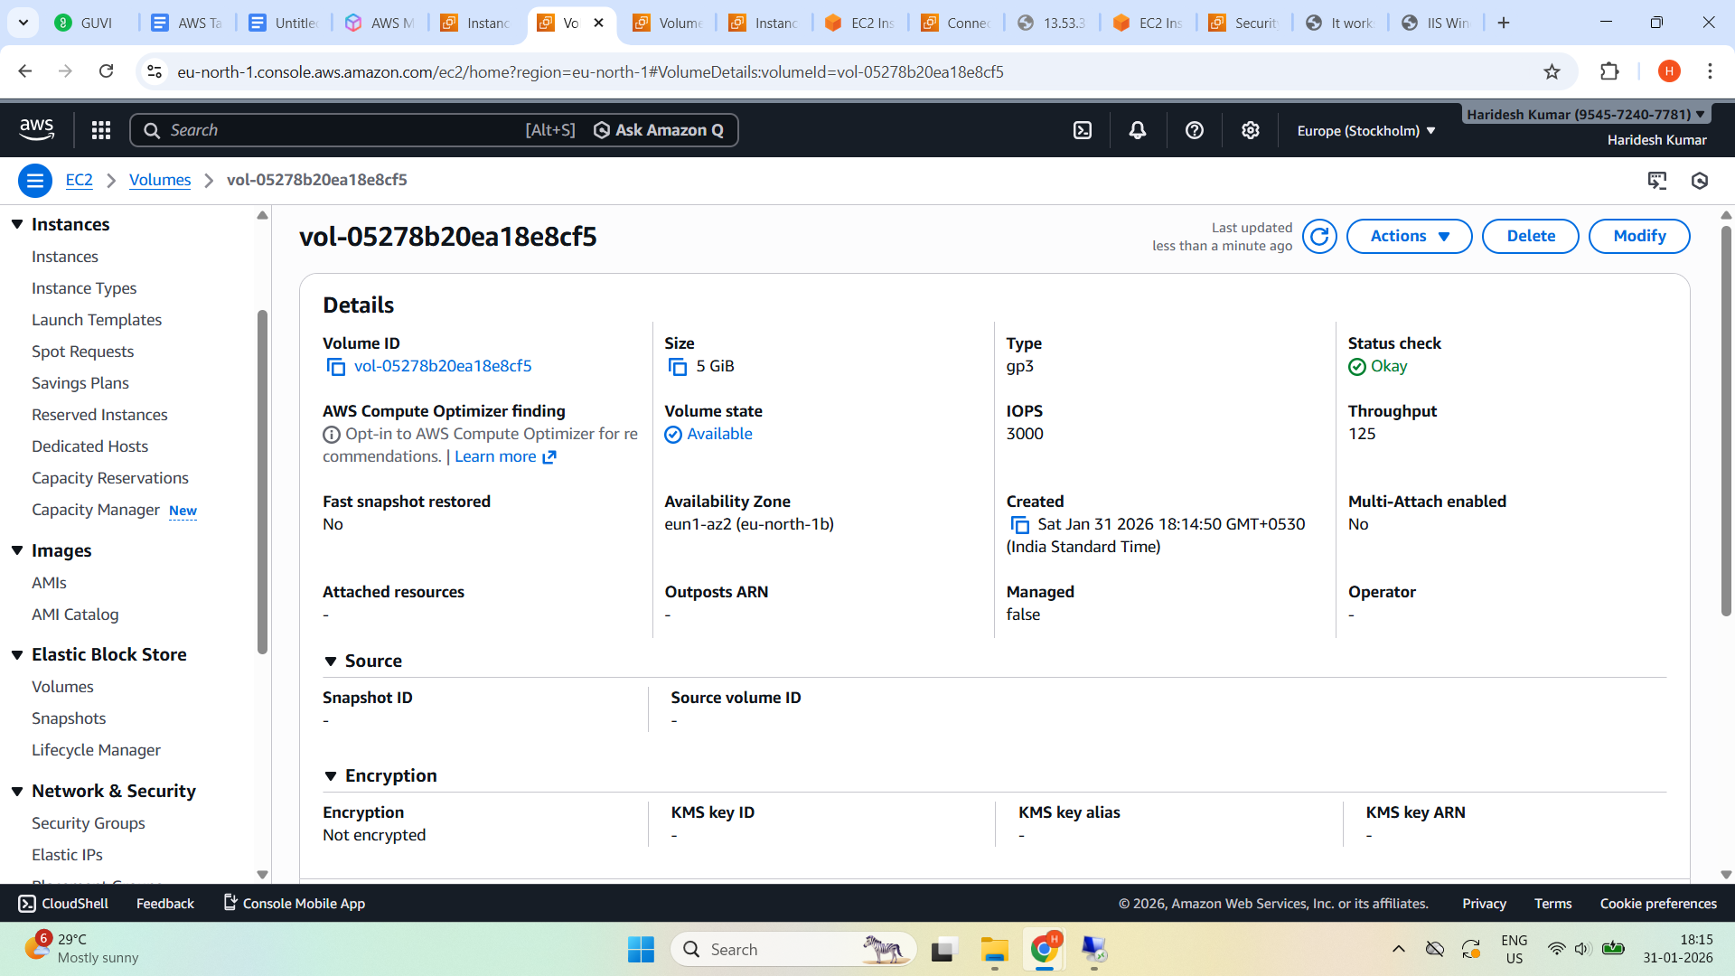

**Attached to windows EC2**

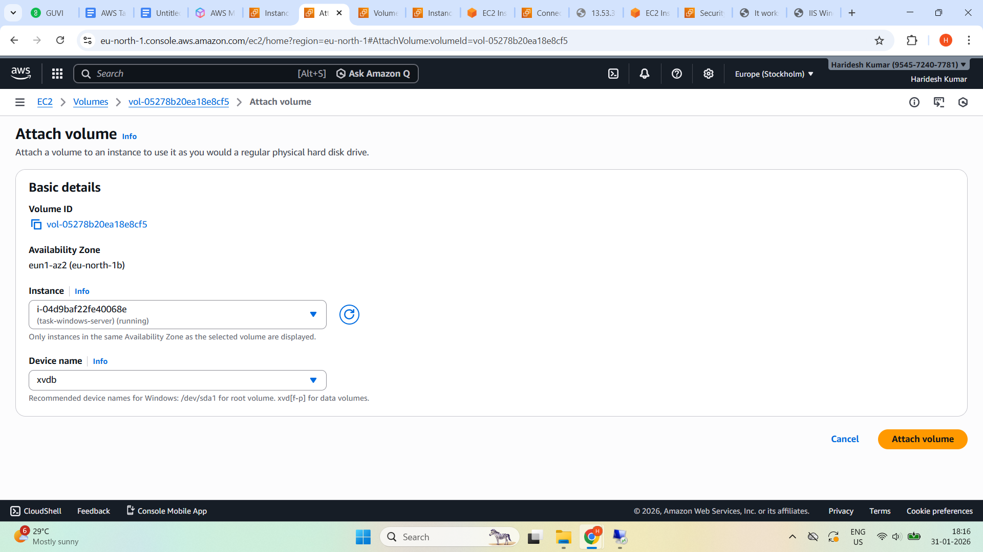

**Volume state -** In-use

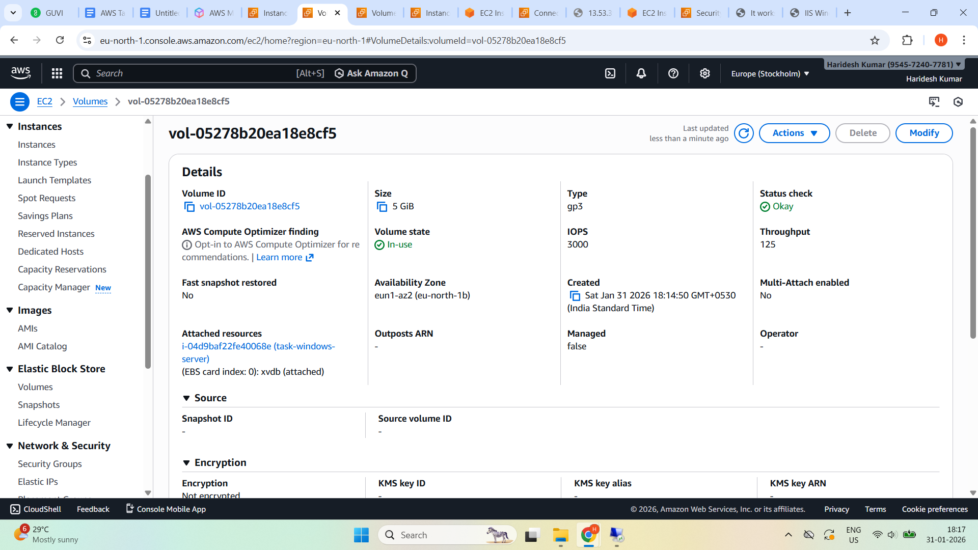

**Login to Windows and Open Disk Management**

**To open Disk Management → Press Windows Key + X**

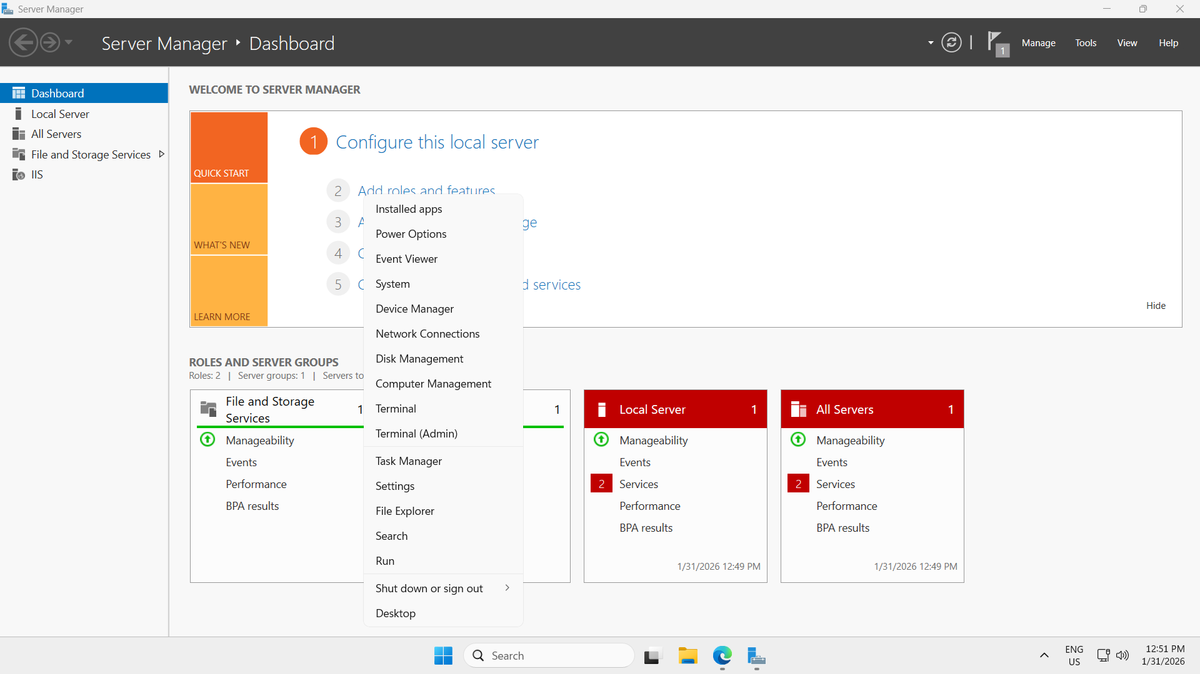

**Initialize Disk**

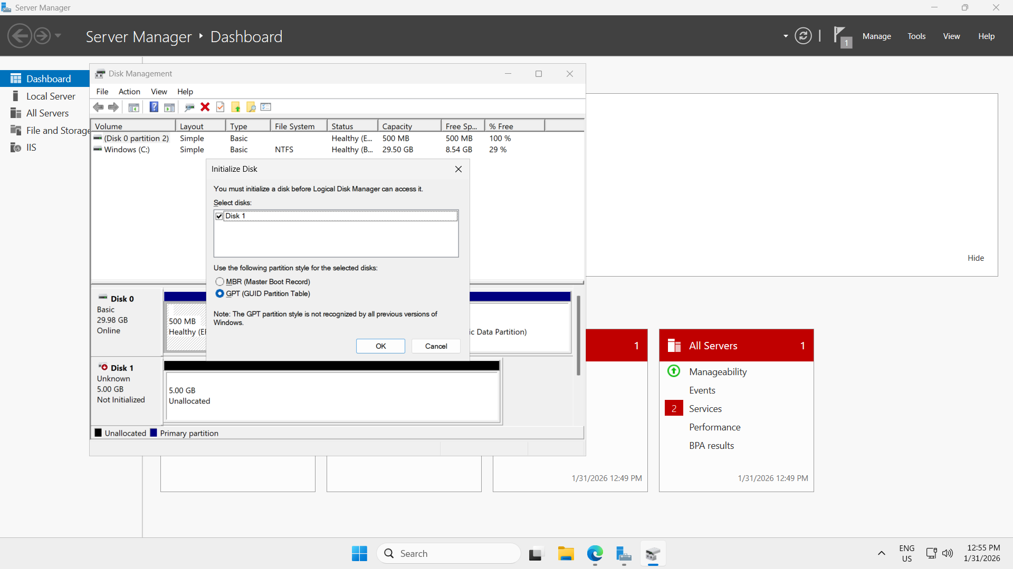

**Right click on BLANK area (4.98 GB - unallocated)**

**Click New Simple Volume**

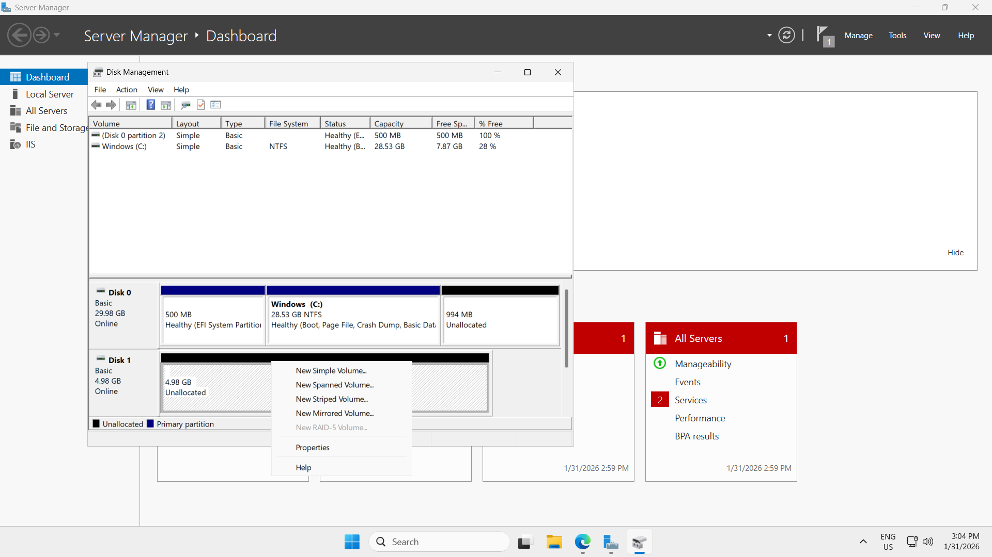

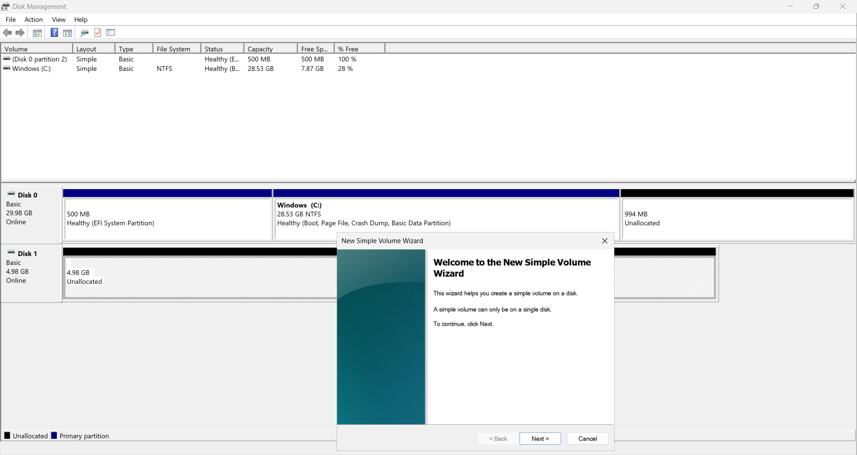

**Use maximum size**

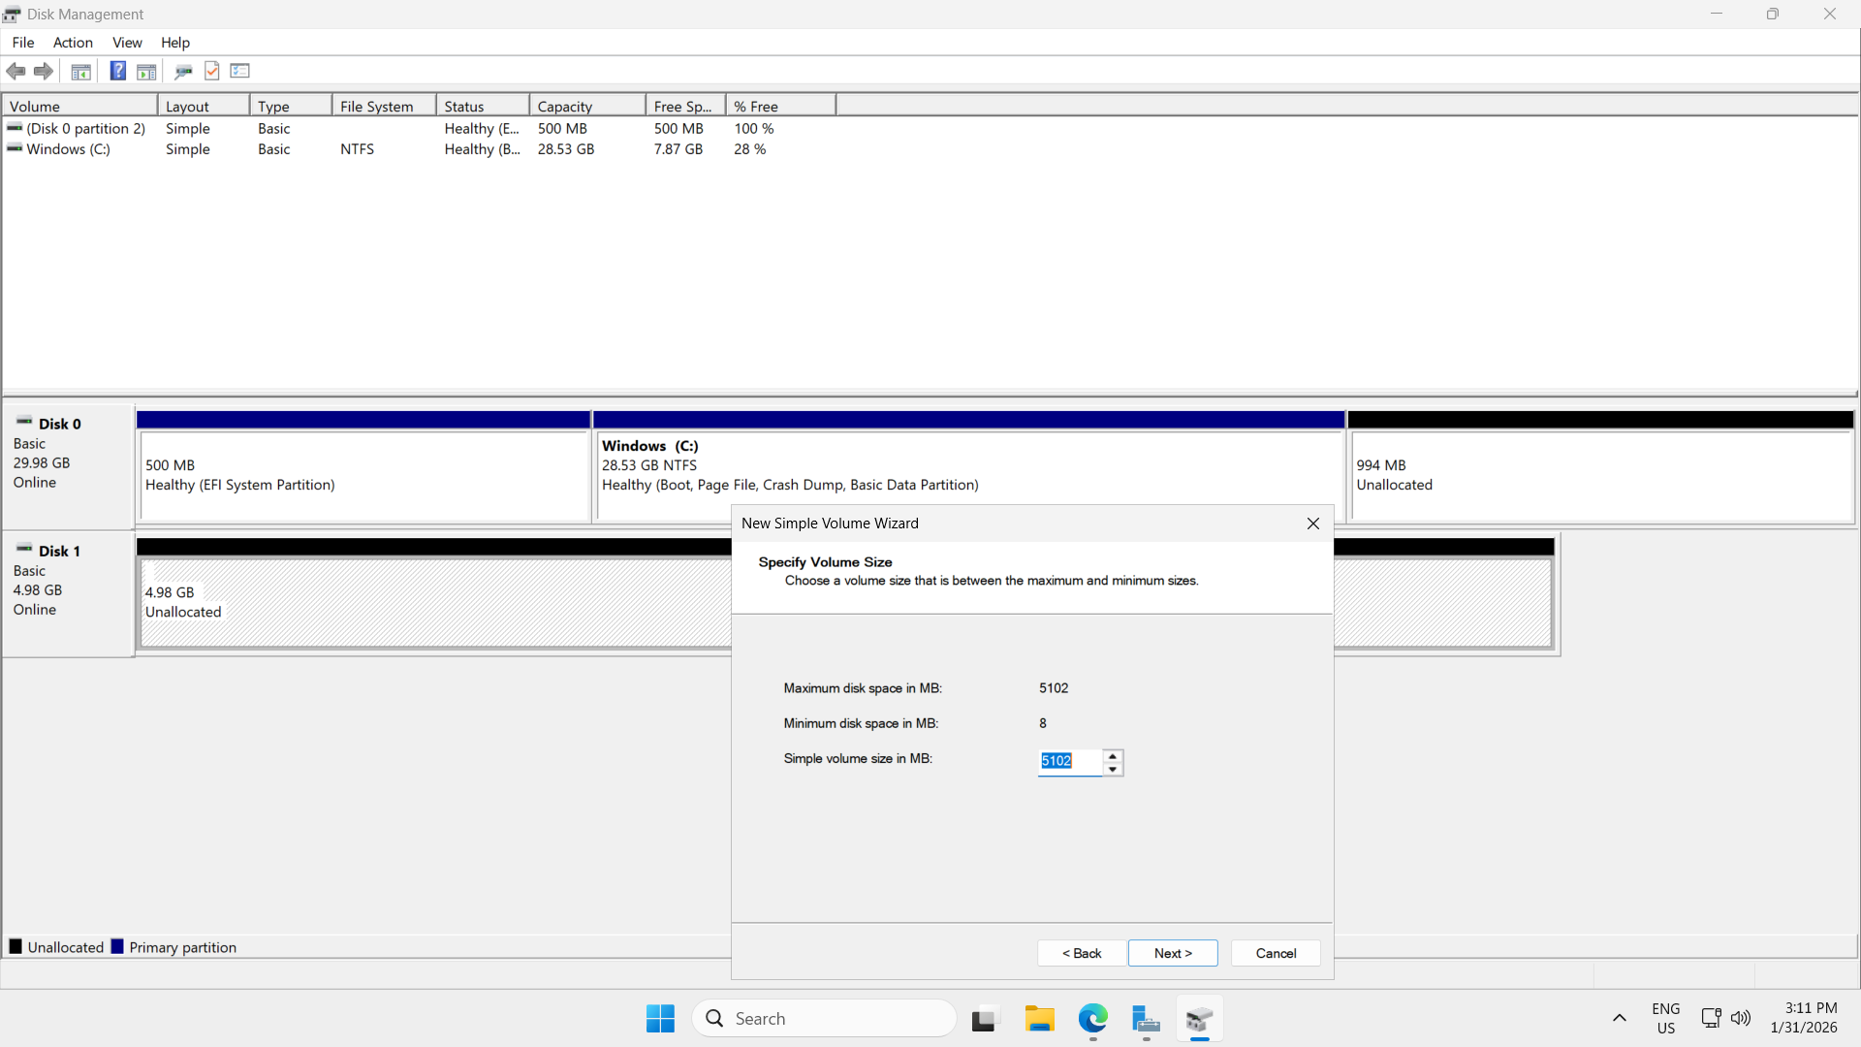

**Assign the following Drive letter : E**

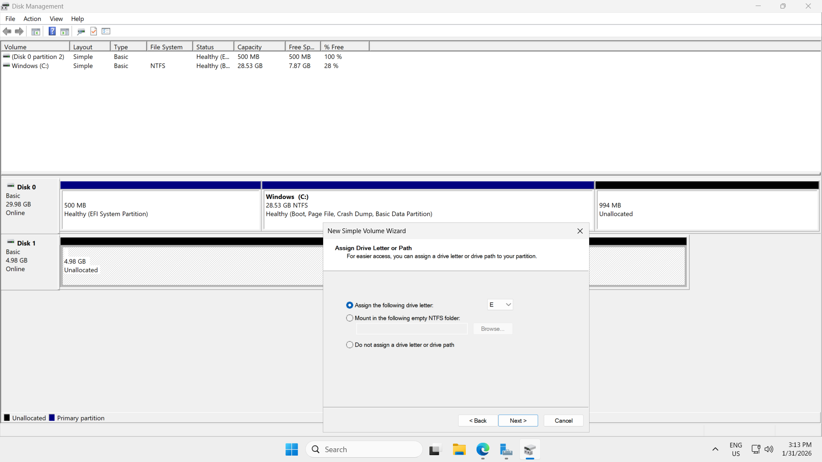

**File system - NFTS and Quick format is checked**

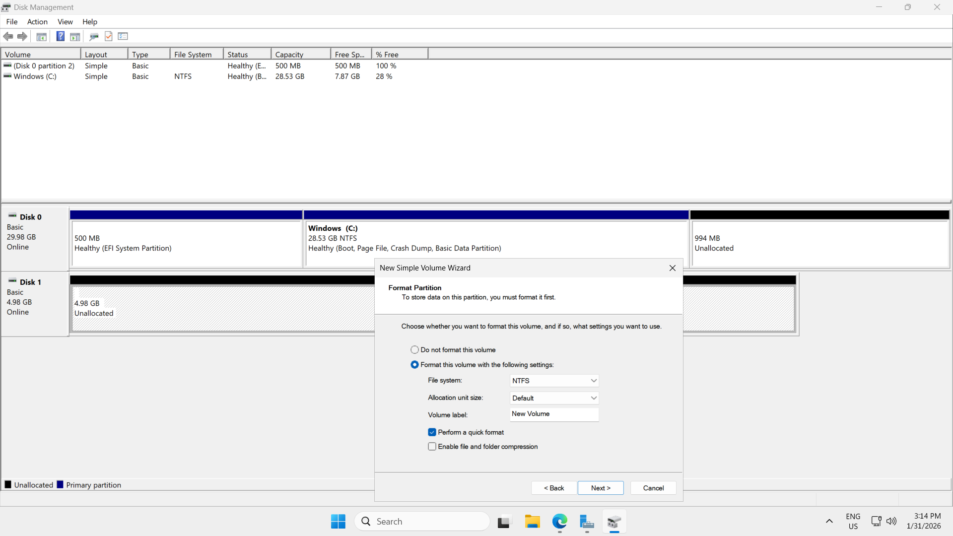

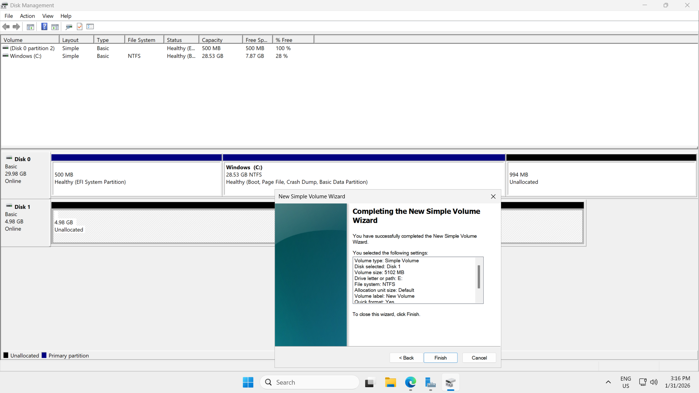

**Click Finish**

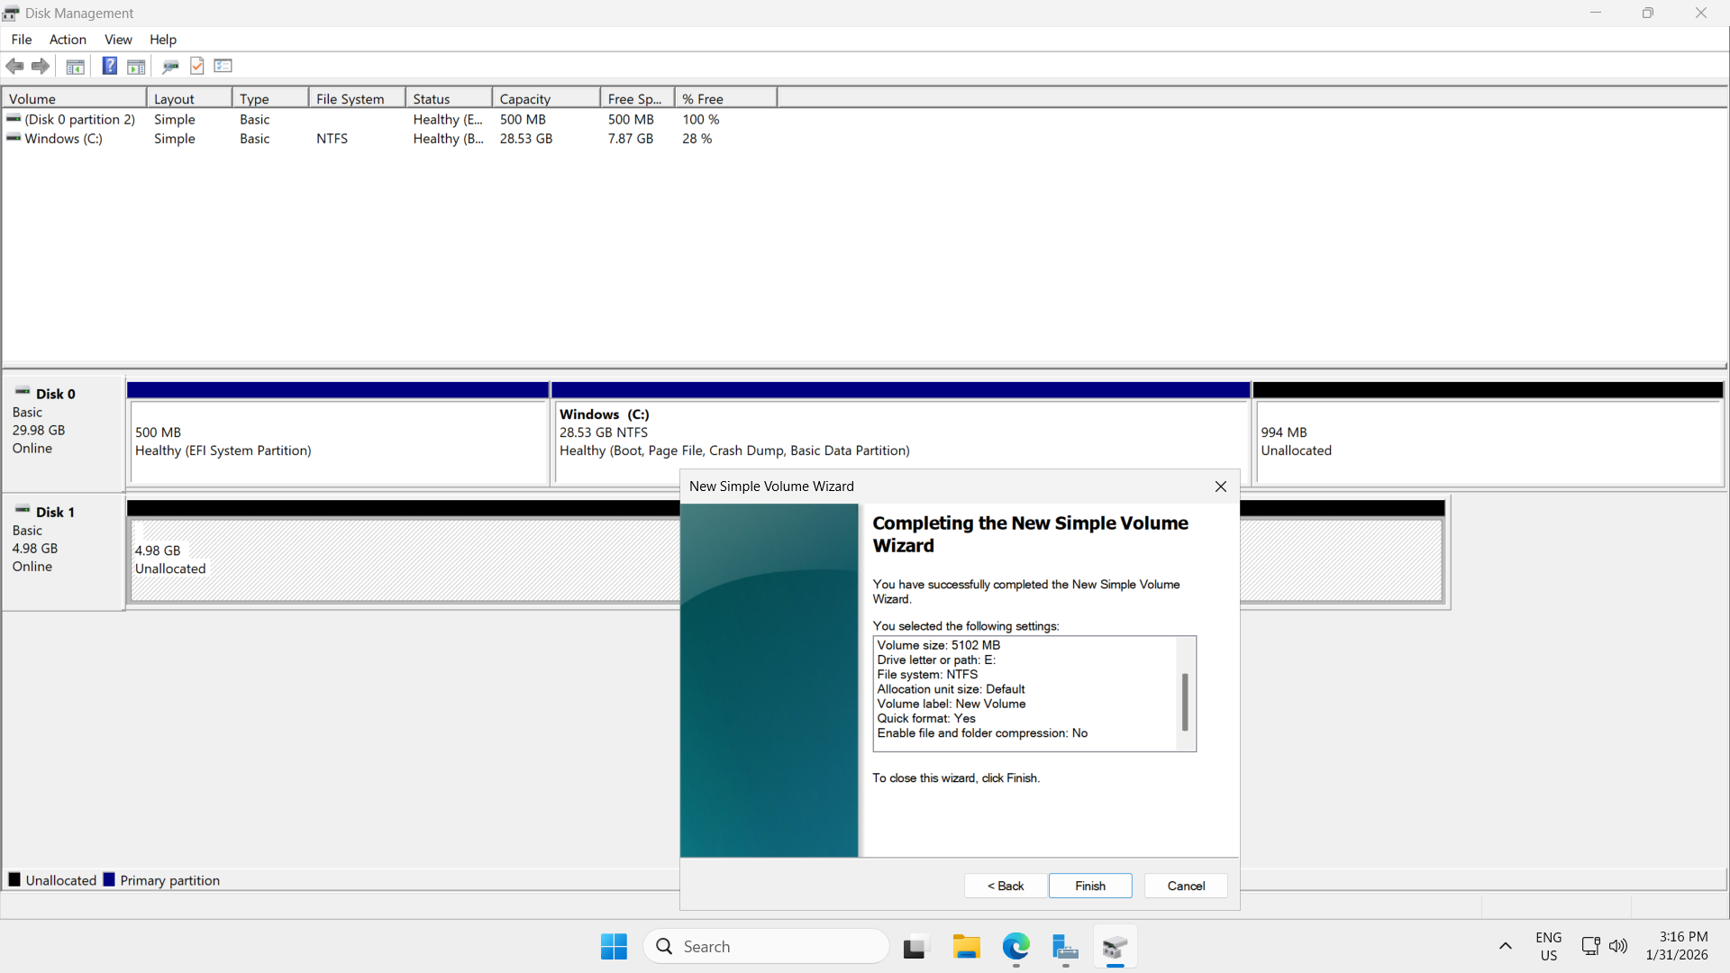

**Final Result**

**Drive E and it should visible in This PC and Drive status - Healthy**

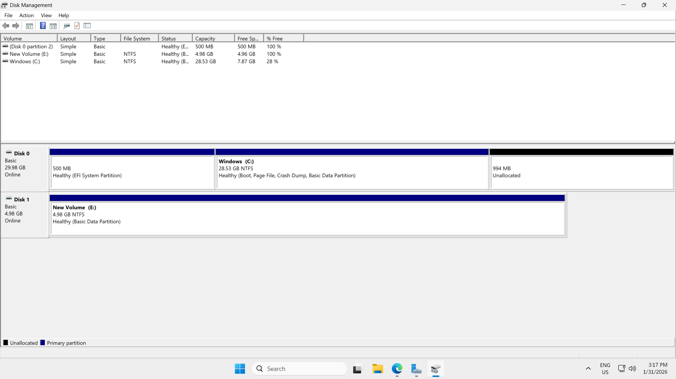

**Screenshot from This PC**

**New Volume E**

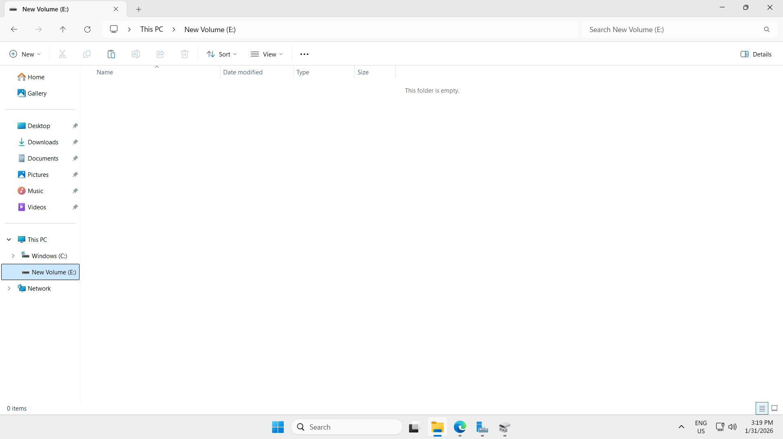

**New Volume E drive Properties**

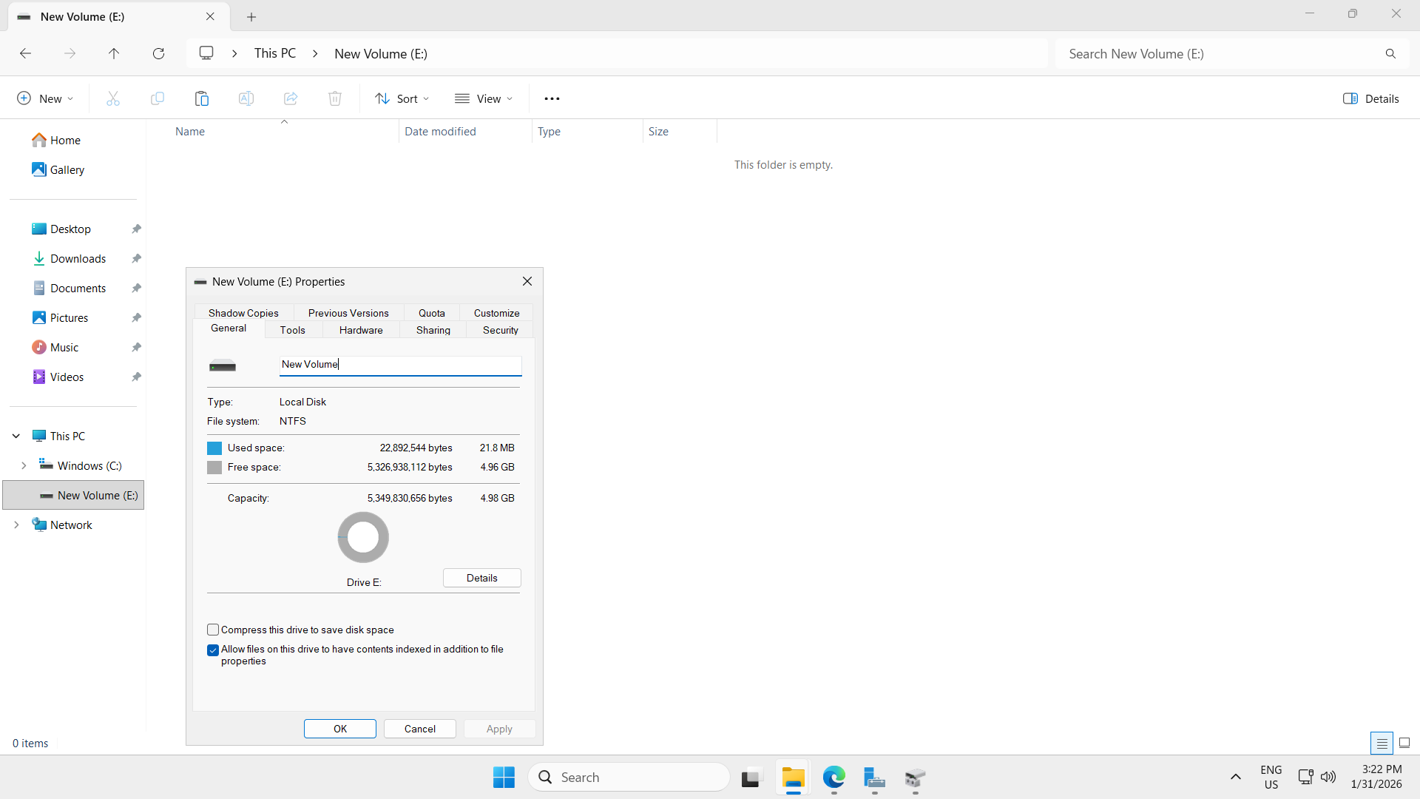

**Create Snapshot of EBS Volume**

**Linux EC2 instnce**

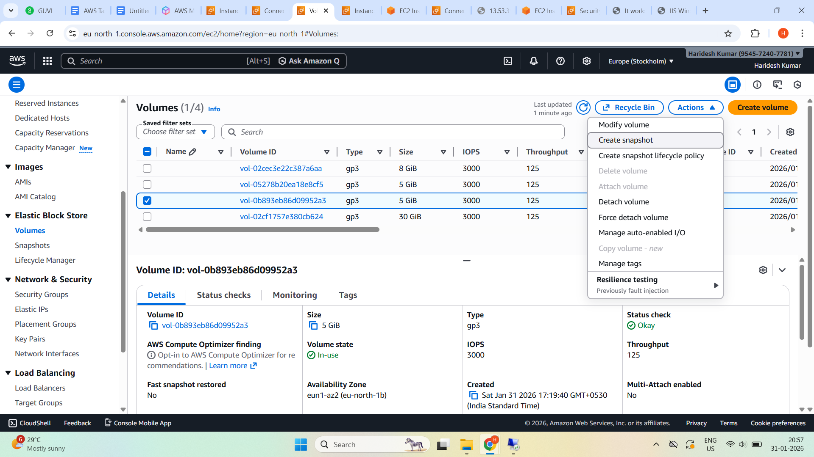

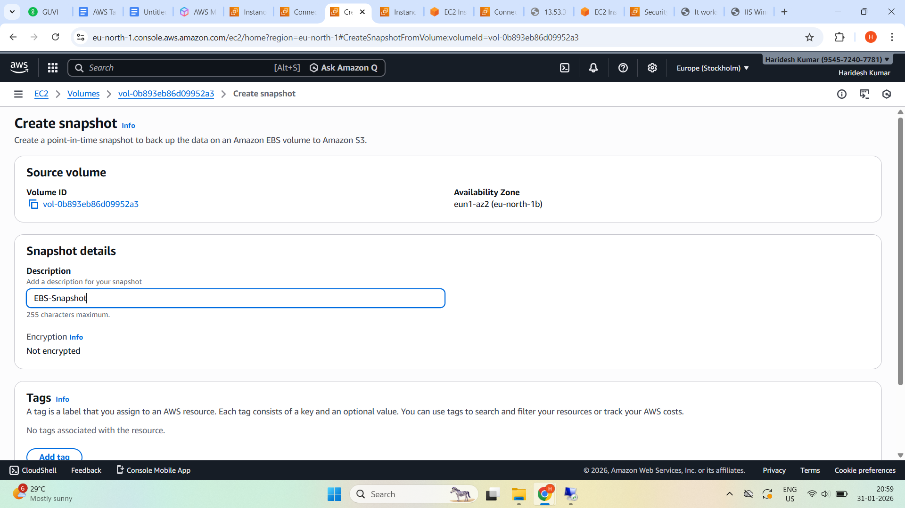

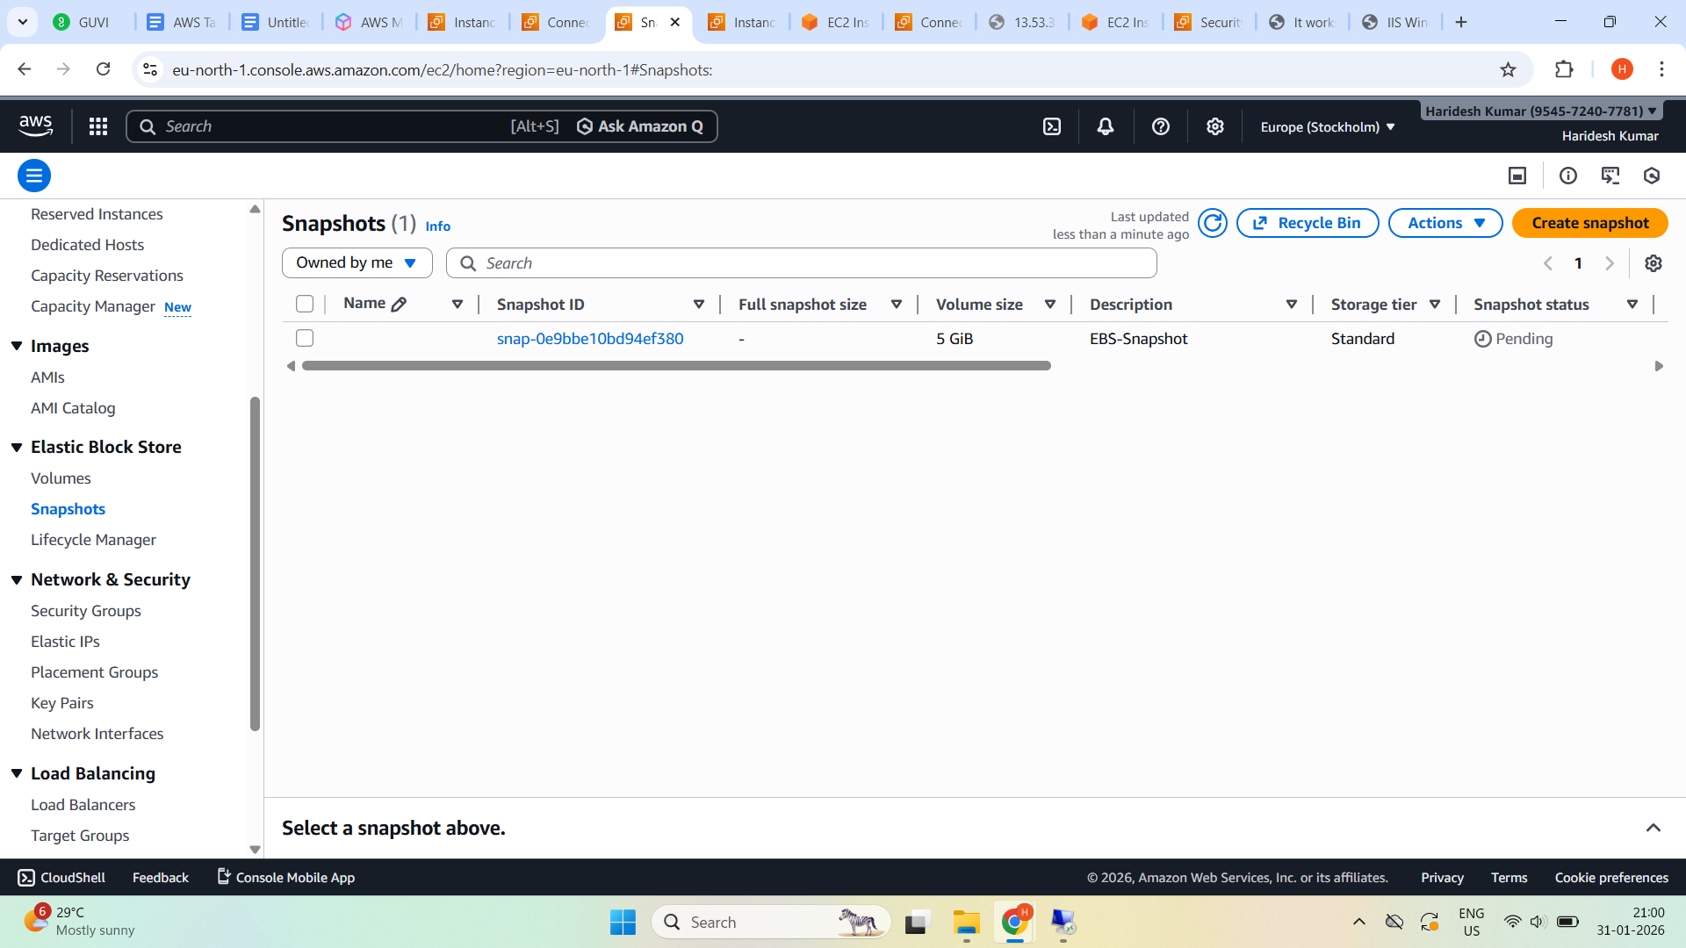

**Snapshot state completed**

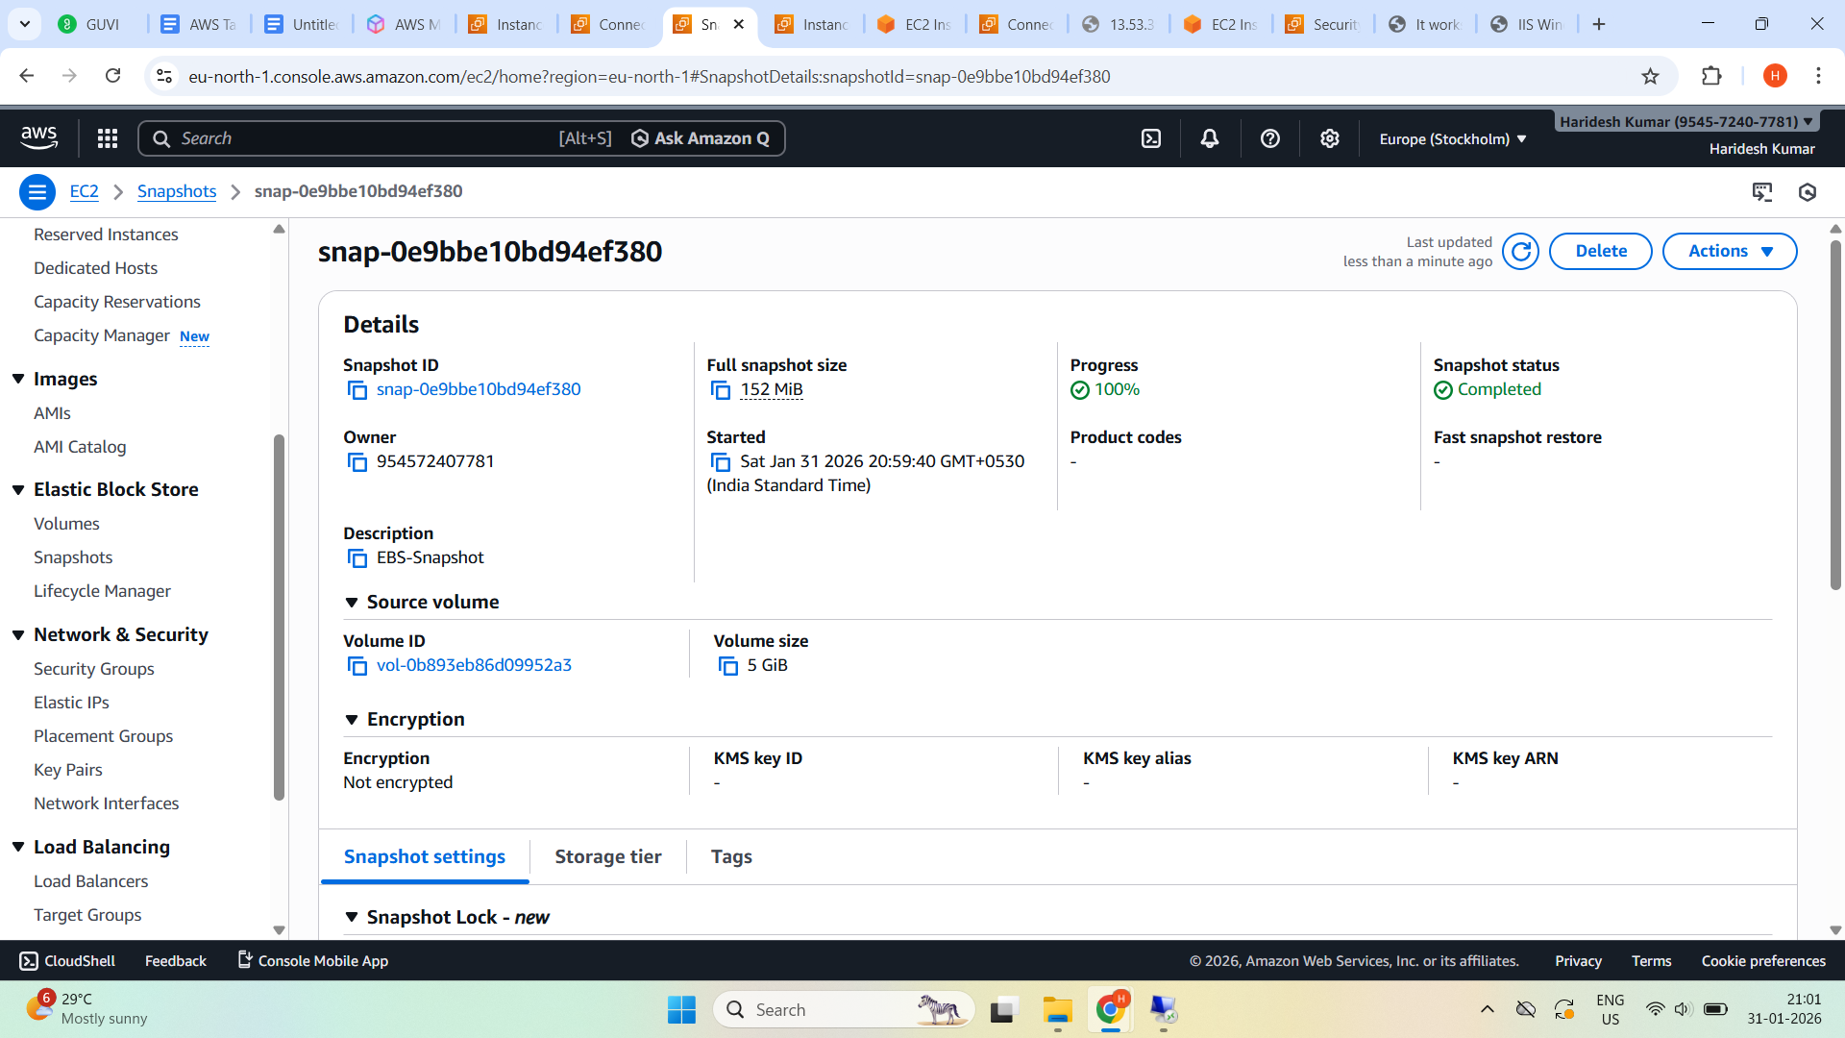

**Windows EC2**

**Snapshot status completed**

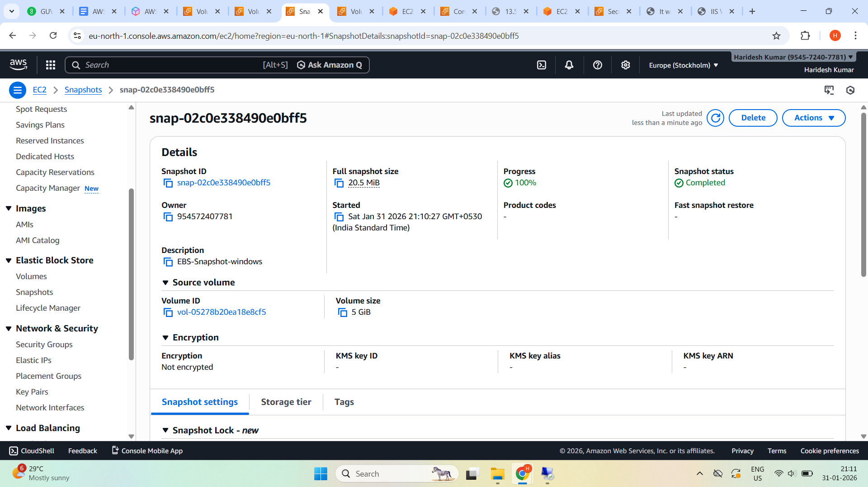

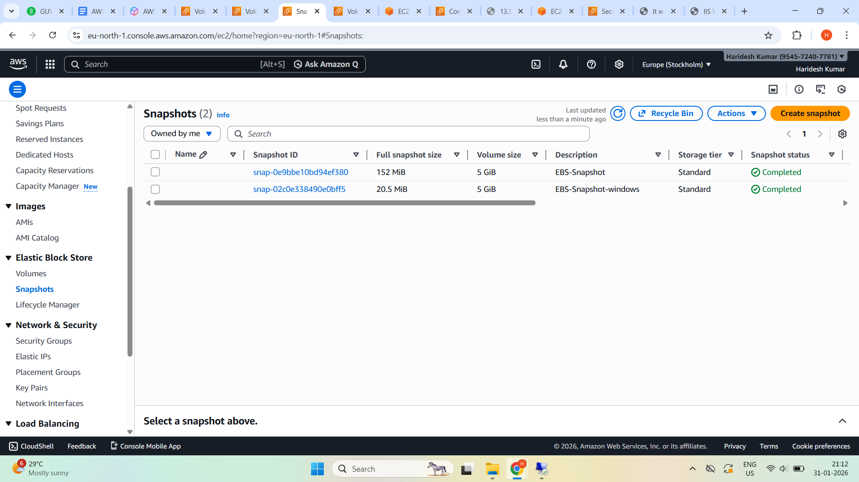

**Create EBS Volume from Snapshot**

**Linux EC2**

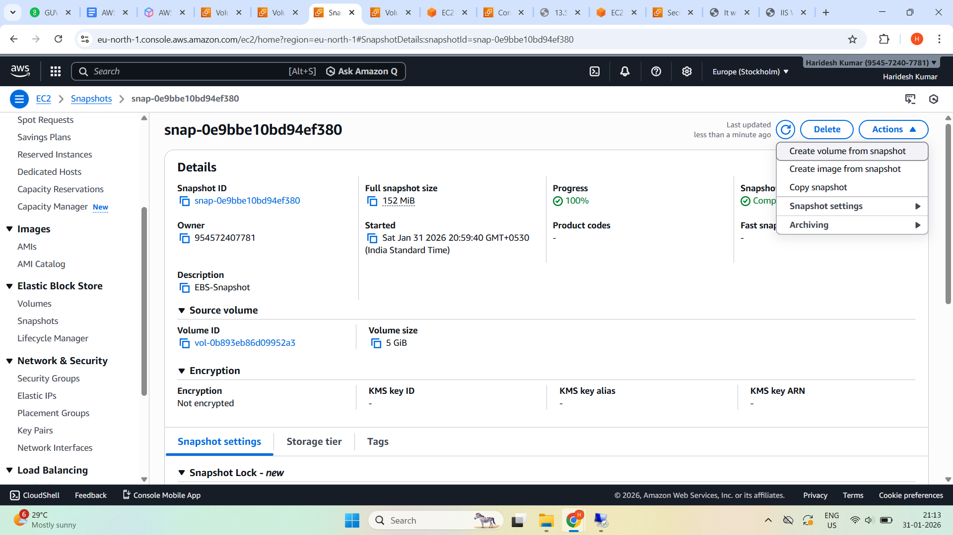

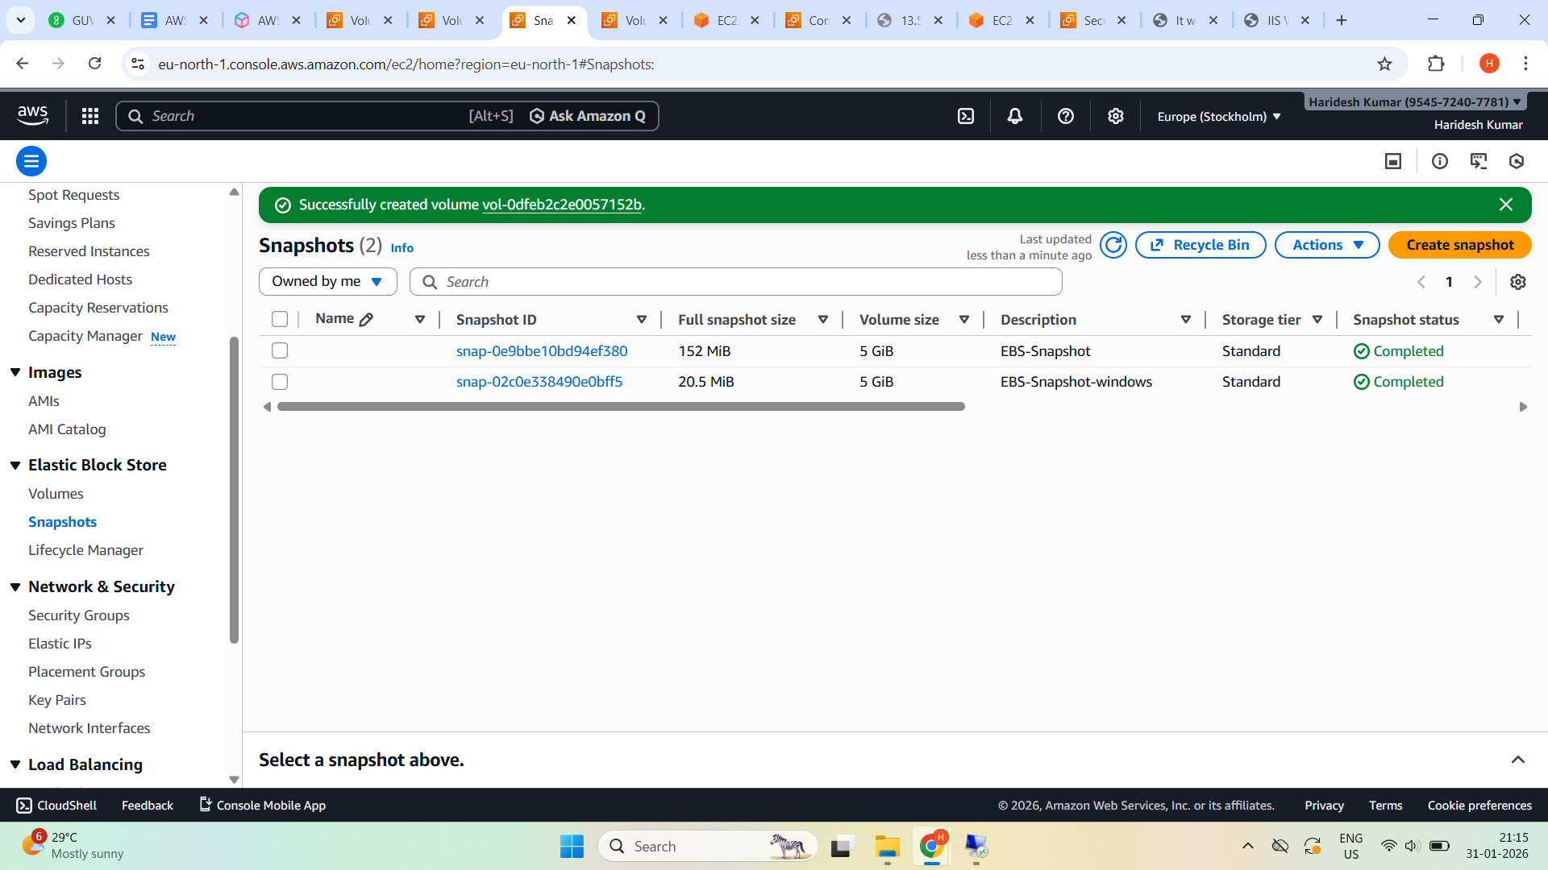

**Volume state - Available**

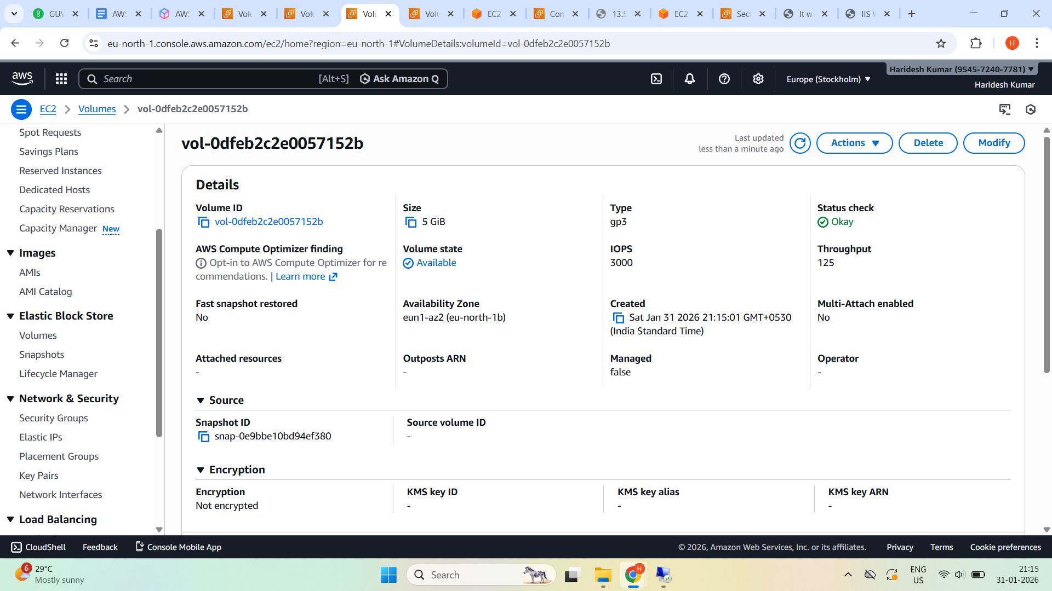

**Create Volume from Snapshot for Windows EC2**

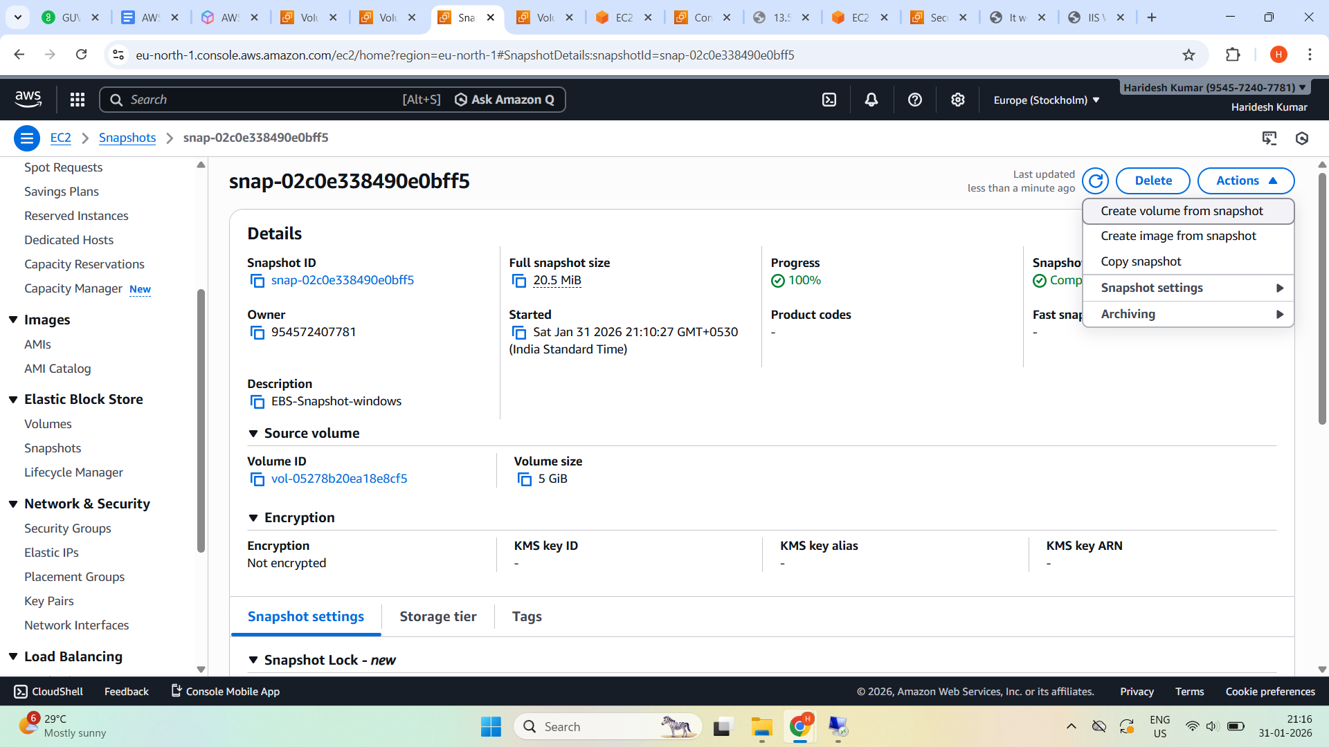

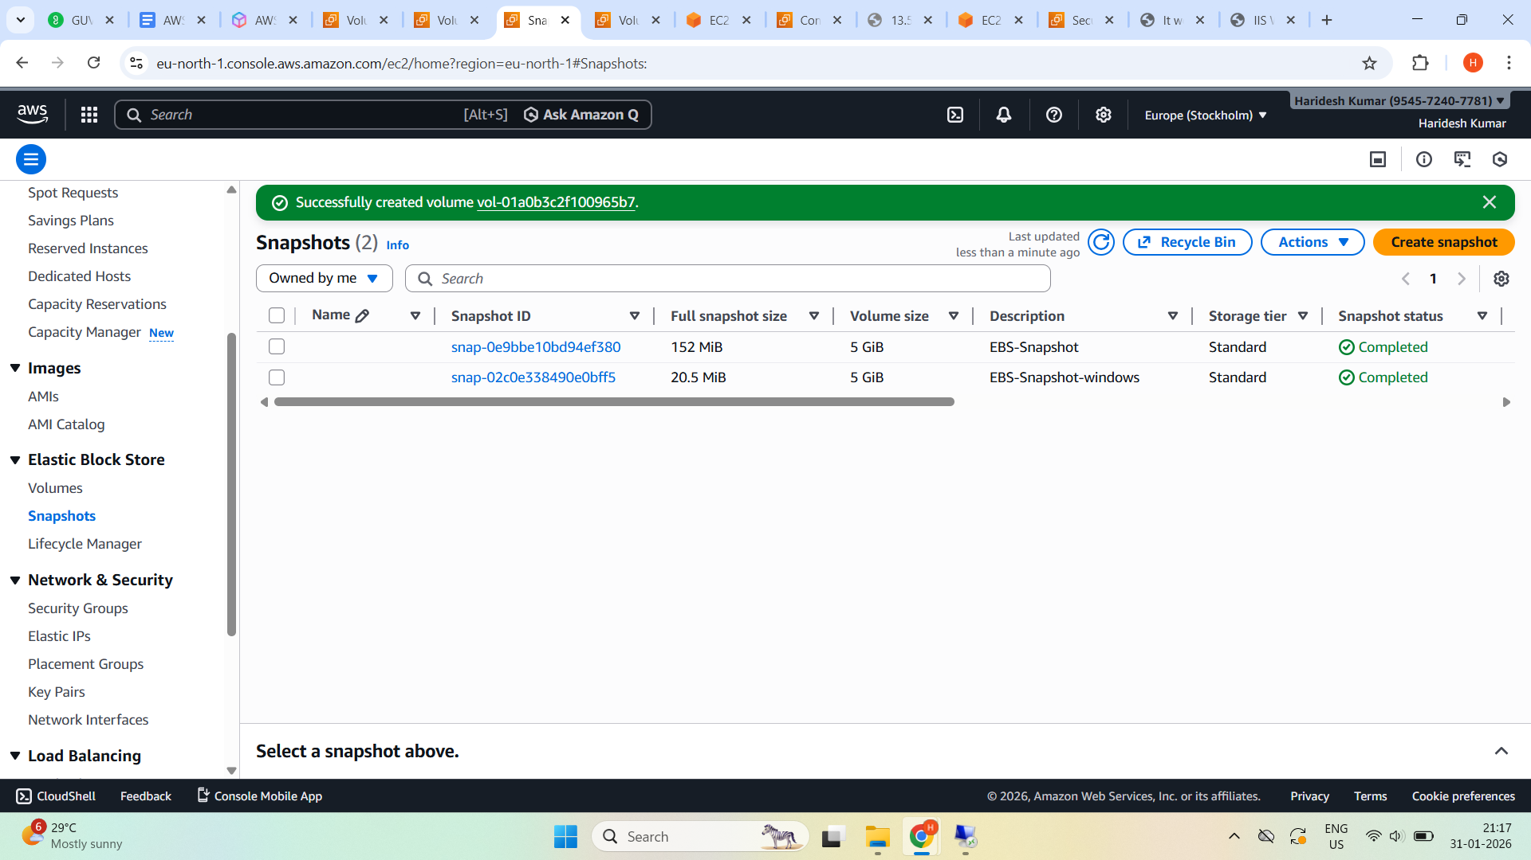

**Volume State - Available**

